SIMON LUCKOW
THEATRICAL PORTFOLIO

simonpluckow@gmail.com
(763) 645-4219
TABLE OF CONTENTS
- Resumes
  - Stage Manager Resume
  - Theatrical Resume
- Technical Experience
  - Stage Management
    - Hershel and the Hanukkah Goblins- Stage Manager
    - Holiday Inn- Stage Manager
    - The Night Witches- Stage Manager
    - A Year with Frog and Toad KIDS/Winnie the Pooh KIDS- Stage Manager
    - Out of Darkness- Stage Manager
    - You’re a Good Man, Charlie Brown- Stage Manager
    - Romeo and Juliet- Stage Manager
    - Much Ado About Nothing- Stage Manager
    - One Act Festival- Production Stage Manager
    - These Shining Lives- Stage Manager
    - Little Women- Assistant Stage Manager
    - Twelfth Night- Assistant Stage Manager
  - Props Technician
    - Anything Goes
    - The Hobbit
  - Sound Technician
    - A Christmas Carol
    - Little Women
  - Scenic Technician
    - Twelfth Night
    - The Lightning Thief
  - Costume Technician
    - Ramona Quimby
    - Peter Pan: A Musical Adventure
  - Miscellaneous Positions
    - Sound Board Operator- Ramona Quimby
    - Hair/Makeup Assistant- Ramona Quimby
- References
- Complete Works

RESUMES

SIMON LUCKOW STAGE MANAGER
Cell Phone: (763) 645-4219 Email: simonpluckow@gmail.com
STAGE MANAGEMENT EXPERIENCE
University of Northwestern - Saint Paul
 |  | Holiday Inn | SM | Jennifer Hunter (DIR) | Nov 2024
 |  | The Night Witches | SM | Jennifer Hunter (DIR) | Sep 2024
 |  | The Last 10 Years- UNW Theatre | Event SM | Jennifer Hunter | May 2024
 |  | Out of Darkness- UNW Dance Theater | SM | Jolene Konkel | Apr 2024
 |  | You’re a Good Man Charlie Brown | SM | Jennifer Hunter (DIR) | Feb 2024
 |  | Romeo & Juliet | SM | Jennifer Hunter (DIR) | Sep 2023
 |  | One Act Festival | PSM | Jennifer Hunter | May 2023
 |  | Little Women | ASM | Grace Wright (SM) | Nov 2022
 |  | These Shining Lives | SM | Jennifer Hunter (DIR) | Sep 2022
 |  | Twelfth Night | ASM | Annika Mossberg (SM) | Apr 2022
Jewish Community Center of Saint Paul
 |  | Hershel & the Hannukah Goblins | SM | Hannah MacKenzie-Margulies | Dec 2024
Morningside Theater Company
 |  | A Year with Frog and Toad KIDS | ASM | Ella Williams (DIR) | Jul 2024
 |  | Winnie the Pooh KIDS | SM | Ella Williams | Jul 2024
Classical Actors Ensemble
 |  | Much Ado About Nothing | SM | Joseph Papke (DIR) | Jun 2023
OTHER TECHNICAL EXPERIENCE
University of Northwestern - St. Paul
 |  | The Hobbit | Props Tech | Megan Liesmaki (DIR) | Apr 2023
 |  | Anything Goes | Props Tech | Alita Robertson (DES) | Mar 2023
 |  | Little Women | Sound Tech | Iris Dodge (TD) | Nov 2022
 |  | Twelfth Night | Scenic Tech | Iris Dodge (TD) | Apr 2022
 |  | The Lightning Thief | Scenic Tech | Iris Dodge (TD) | Feb 2022
 |  | Ramona Quimby | Sound Board Op | Annika Mossberg (SM) | Dec 2021
 |  | Peter Pan: A Musical Adventure | Costume Tech | Jennifer Hunter (SUP) | Oct 2021
 |  | Peter Pan: A Musical Adventure | Flight Crew | Nate Stevens (Flight Head) | Oct 2021
RELATED TECHNICAL EXPERIENCE
Stage Technician at Knight Performance Hall, University of Northwestern - St, Paul, St. Paul, MN
 |  | Duties: Assist in Scenic, Lighting, Sound, and other performance related technical duties as needed.
EDUCATION
 | B.S. in Theater, Minor in Marketing from University of Northwestern St. Paul, MN (antic. Spring 2025)
AWARDS AND RECOGNITIONS
KCACTF Region 5
 |  | Meritorious Achievement in Stage Management |  | Romeo and Juliet | Jan 2024
 |  | Meritorious Achievement in First Time Stage Management |  | These Shining Lives | Jan 2023
REFERENCES
Iris Dodge, Technical Director at University of Northwestern, Saint Paul
 |  | iddodge@unwsp.edu | (715) 360-0547
Jennifer Hunter, Artistic Director at University of Northwestern, Saint Paul
 |  | jkhunter@unwsp.edu | (616) 340-9606
Sarah Prow, Lighting Systems Engineer, Knight Performance Hall, University of Northwestern, Saint Paul
 |  | smprow@unwsp.edu | (651) 592-2924
SPECIAL SKILLS
 |  | Proficiency in Microsoft/Google Suites, QLab, Grand MA2/3 Light Board, Digico SD10 Sound Board, Soldering, Proficiency w/ Power Tools
SIMON LUCKOW THEATRICAL RESUME
Cell Phone: (763) 645-4219 Email: simonpluckow@gmail.com
ACTING EXPERIENCE
University of Northwestern St. Paul, St. Paul, MN
 | The Cat in the Hat | Cat | Mitch Geiken |  | 2024
 | Twas’ the Night Before Christmas | Ensemble | Mitch Geiken |  | 2023
 | Anastasia | Dance Ensemble | Jennifer Hunter |  | 2023
 | The Hobbit | Thorin | Megan Liesmaki |  | 2023
 | Anything Goes | Dance Ensemble | Jennifer Hunter |  | 2023
 | A Christmas Carol | Ensemble | Daniel McLaughlin |  | 2022
 | The Lightning Thief | Ensemble | Jennifer Hunter |  | 2022
 | Peter Pan: A Musical Adventure | Cecco | Jennifer Hunter |  | 2021
TECHNICAL EXPERIENCE
Jewish Community Center of Saint Paul
 | Hershel & the Hannukah Goblins | SM | Hannah MacKenzie-Margulies |  | 2024
Morningside Theater Company
 | A Year with Frog and Toad KIDS | ASM | Ella Williams |  | 2024
 | Winnie the Pooh KIDS | SM | Ella Williams |  | 2024
Classical Actors Ensemble
 | Much Ado About Nothing | SM | Joseph Papke |  | 2023
University of Northwestern St. Paul, St. Paul, MN
 | Holiday Inn | SM | Jennifer Hunter |  | 2024
 | The Night Witches | SM | Jennifer Hunter |  | 2024
 | The Last 10 Years- UNW Theater | Event SM | Jennifer Hunter |  | 2024
 | Out of Darkness- UNW Dance Theater | SM | Jolene Konkel |  | 2024
 | You’re a Good Man, Charlie Brown | SM | Jennifer Hunter |  | 2024
 | Romeo & Juliet | SM | Jennifer Hunter |  | 2023
 | One-Act Festival | PSM | Jennifer Hunter |  | 2023
 | The Hobbit | Props Tech | Megan Liesmaki (DIR) |  | 2023
 | Anything Goes | Props Tech | Alita Robertson (DES) |  | 2023
 | A Christmas Carol | Sound Tech | Zach Morse (DES) |  | 2022
 | Little Women | ASM | Grace Wright (SM) |  | 2022
 | Little Women | Sound Tech | Iris Dodge (TD) |  | 2022
 | These Shining Lives | SM | Jennifer Hunter (DIR) |  | 2022
 | Twelfth Night | ASM | Annika Mossberg (SM) |  | 2022
 | Twelfth Night | Scenic Tech | Iris Dodge (TD) |  | 2022
 | The Lightning Thief | Scenic Tech | Iris Dodge (TD) |  | 2022
 | Ramona Quimby | Sound Board Op | Annika Mossberg (SM) |  | 2021
 | Peter Pan: A Musical Adventure | Flight Crew | Nate Stevens (Flight Head) |  | 2021
EDUCATION
 | Bachelor of Science in Theater from University of Northwestern St. Paul, MN (anticipated 2025)
AWARDS AND RECOGNITIONS
KCACTF Region 5
 | Meritorious Achievement Stage Management- Romeo and Juliet |  |  | 2024
 | Meritorious Achievement in First Time Stage Management- These Shining Lives |  |  | 2023
SPECIAL SKILLS
 | Driver’s License, Microsoft Suite, Google Suite, Social Media, 6 Years Voice, QLab

TECHNICAL EXPERIENCE

STAGE MANAGEMENT

HERSHEL & THE HANUKKAH GOBLINS
Stage Manager

Hannah MacKenzie Margulies- Director/Choreographer

Produced by the Jewish Community Center of Saint Paul
December 2024
STAGE MANAGER
For this dance production, I was responsible for most of the technical elements of the show. This included the usual things like calling cues and maintaining the stage, but I was also heavily involved with the lighting and sound operations as the overall technical expert in the space. Anything that was not directly related to the choreography and direction of the show fell under my purview.
I was only on board this show for two weeks, so it was a quick learning process and fast turnaround. As it was a dance concert, I developed my own “script” to call from based on visual cues that the dancers provided. I mostly called light cues, with a few actor entrances and band G-O cues as well.
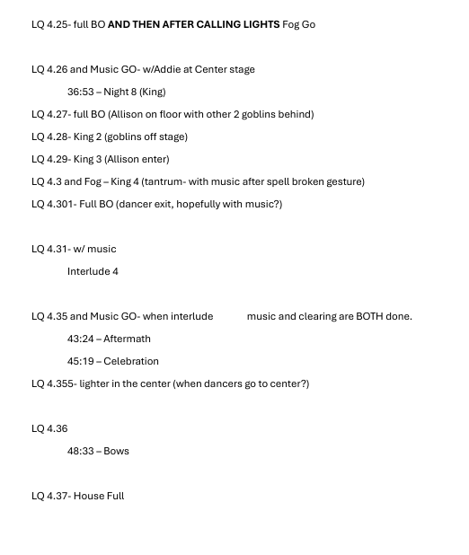
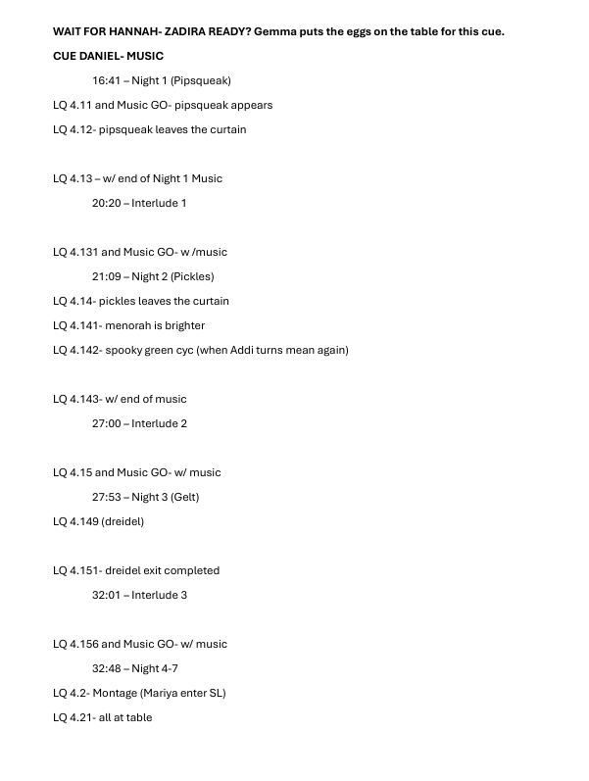
My greatest contributions to this show were my knowledge or how things worked, and my organizational ability to make sure all the background elements were taken care of. This allows the directors and performers to be singularly focus ed on the art they were creating.
HOLIDAY INN
Stage Manager

Jennifer Hunter- Director
Iris Dodge- Technical Director

Produced by University of Northwestern St. Paul
November 2024
STAGE MANAGER
Holiday Inn is by far the largest and most complex show I have ever worked on. We had massive sets and more costumes than I could count. There were a relentless amount of cues. The cast was large.
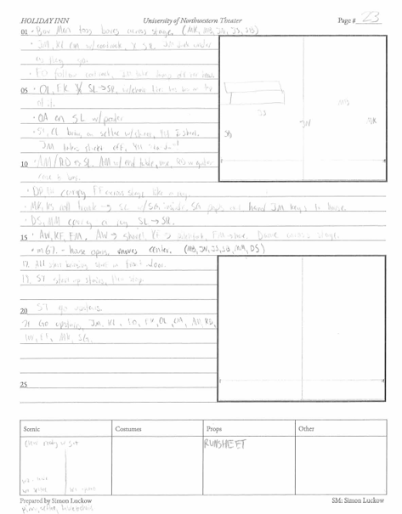
The blocking of the show was the first big challenge we faced. We had a lot of material to cover and a limited amount of time to do it. Moving quickly was a necessity, as was accuracy. I marked down scenic info and placement of actors on the ground plans, and wrote instruction in the lines. The boxes on the bottom were used to take in other information as I deemed in necessary in their related categories.
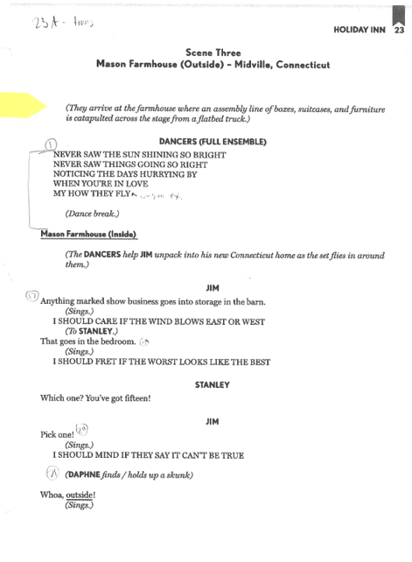

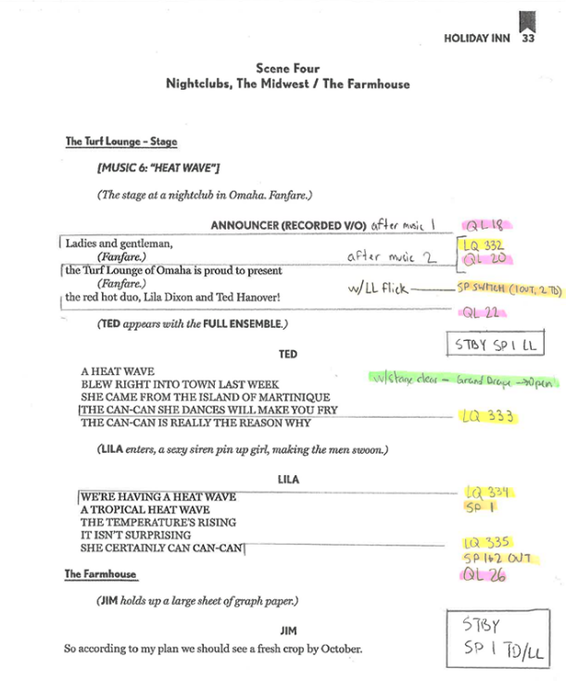

The calling script was just as intense. There were many moments where split seconds of difference made large impacts. I used different colors to differentiate types of cues, and made sure all the pages were perfect and neat to eliminate the possibility of error.

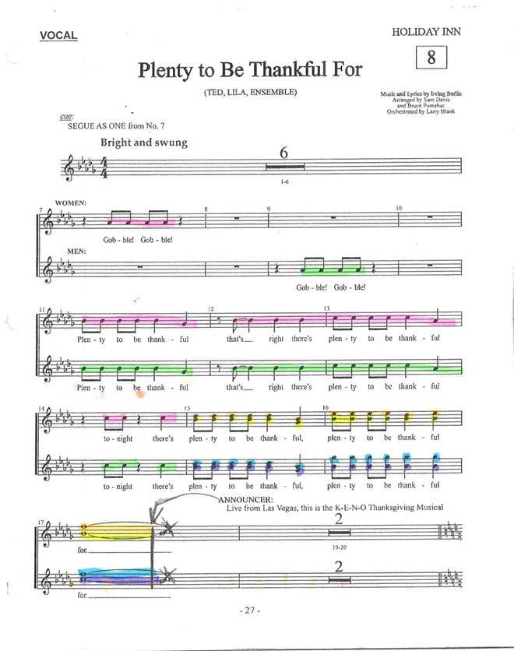
I was also able to use my music skills again with the production. I read music well. It helps with calling, but it also helped me track with voice parts were which during music rehearsals. Just like a stage manager will fill actors in on blocking they miss and other rehearsal information, I was able to instruct actors on what their parts were in any given ensemble number. This ended up saving us a massive amount of time during music rehearsals, as we could focus on refinement instead of learning.

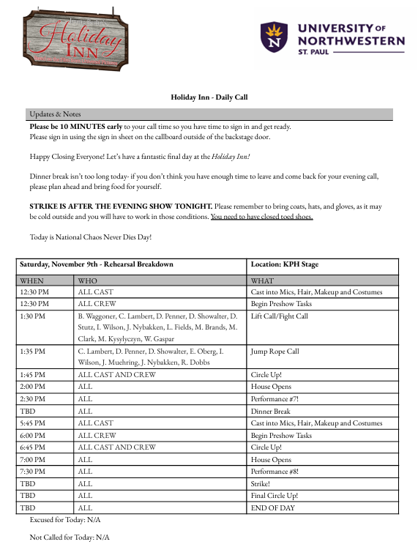
The daily call! I put out all kinds of information in the notes section of the call for the cast and crew, and then send detailed schedules in every call for the next day. This keeps all of us on track!

THE NIGHT WITCHES
Stage Manager

Jennifer Hunter- Director
Iris Dodge- Technical Director

Produced by University of Northwestern St. Paul
September 2024
STAGE MANAGER
The Night Witches was one of my favorites I’ve worked on so far. I love our blackbox theater and the intimate environment. I call remotely in that space, which is a fun challenge. But mostly, this script and the energy our company had was electric. It required me to be on my A-Game the entire production.
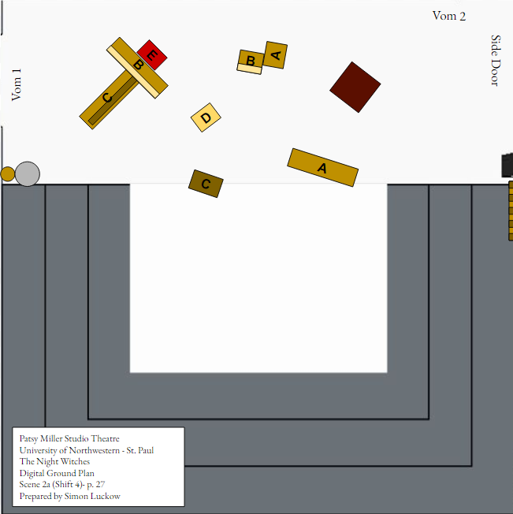
We took a very open-ended approach to creating the scenes in this play. Crates and benches were used to make all the scenic locales, including an airplane in the sky. There were a ton of arrangements of these various pieces throughout the show, and tracking them was important. I created a ground plan for every single scene and movement so actors could reference them for transitions. I also used these in my blocking sheets as they were nice clean images for reference.

I also had a specific and thorough preshow/post show checklist for my crew. We had fog and snow machine, kabuki boxes, and overall a lot of elements in our show that needed heavy monitoring. By making them mark when things got done, it ensured that the correct process was happening each and every day.
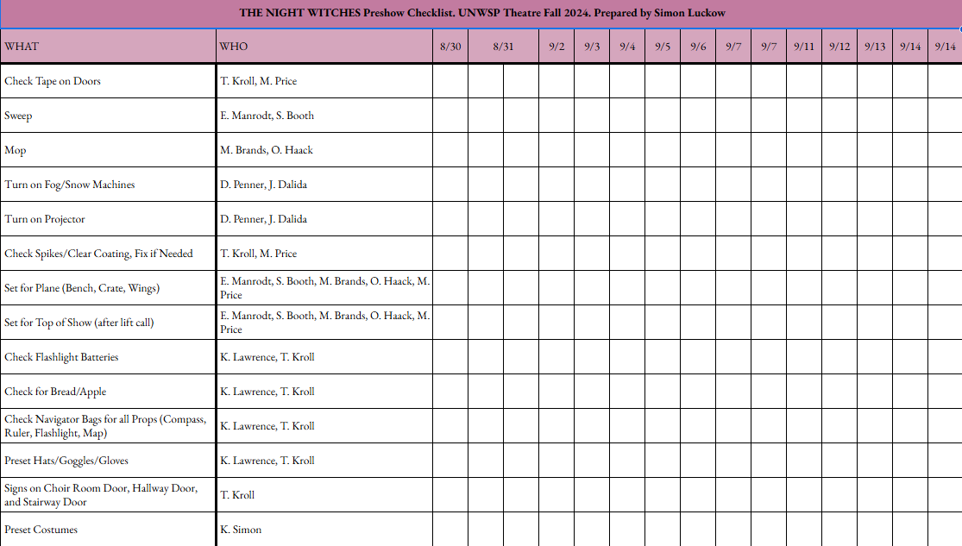

A YEAR WITH FROG AND TOAD KIDS & WINNIE THE POOH KIDS
Stage Manager

Ella Williams- Director

Produced by Morningside Theater Company
June 2024
STAGE MANAGER
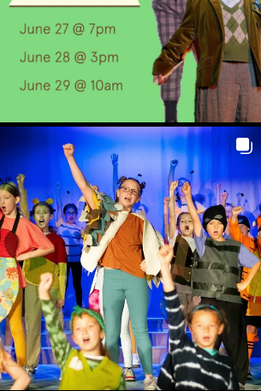
This is probably one of the less conventional shows I have done in terms of my job as the Stage Manager. The KIDS scripts that are licensed through MTI run at approximately thirty minutes. They are small scale, so the director personally oversaw many of the duties I have come to expect as a stage manager. The most important part of this job was maintaining behaviors and order in the rehearsal room. Each of these shows had two casts of forty students actors, aging between 7 and 12 years old. I was constantly watching the actors to make sure everyone was being safe, and gently steering the students when they started to get out of line. In many ways, these shows required me to be more of a youth supervisor than a stage manager.
During the performances, I manned a side of the stage, making sure all props were ready and that the few scene changes happened without any issue. And again, I made sure to keep the students calm and collected while we were backstage.
This show reminded me a lot of my roots with theater- being a kid in a summer program. It was a special experience to be facilitating a program like that, developing a love of theater in a younger generation.

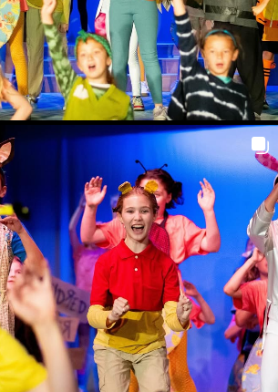
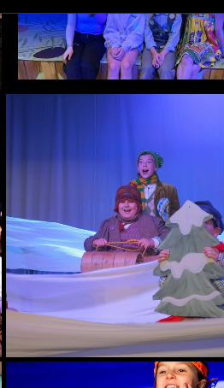
OUT OF DARKNESS
Stage Manager

Jolene Konkel- Director

Produced by University of Northwestern St. Paul
April 2024
STAGE MANAGER
Out of Darkness was my first experience stage managing dance. Two difficulties quickly presented themselves- first, I did not start with the company of dancers until about a week and a half before the show opened. Second, I would not have the convention of a script or dialogue as a reference on when to call cues. What ensued was a crash course in dance terminology and technique for dance stage management. I worked closely with the directors and choreographers to create clear visual marks to call of off in the choreography. Over the tech process, I grew to learn the dances from my eye nearly as well as the dancers knew them in their bodies. Other duties for this show included daily calls, reports, and making sure the stage and theater areas were cleaned and secure.

The biggest paperwork contribution I had was making a Running Plan for the entire show. This detailed which dancers were onstage, where they entered, what costume should they be in, and how the cueing at the top of each song went. These were posted backstage and kept everyone on the same page.

YOU’RE A GOOD MAN, CHARLIE BROWN
Stage Manager

Jennifer Hunter- Director
Iris Dodge- Technical Director

Produced by University of Northwestern St. Paul
February 2024
STAGE MANAGER
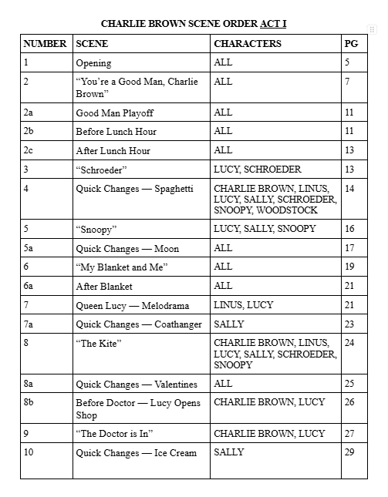
Charlie Brown is the first musical that I have had the opportunity to stage manage. It was also my first time managing the large mainstage theater in our performance hall, as opposed to the downstairs studio theater. The larger scale came with challenges. With a larger stage, the possibilities for staging were exponentially larger. It also required a larger effort in coordinating with many more people to ensure the rehearsal hall and other aspects of production would operate smoothly.
Charlie Brown is a strange show. It flows between vignettes without much of a traditional storyline. My actors made frequent comment of this, so I created this scene order document to help their mental tracking. It dictated what the scene was and who was involved in each scene. This helped both actors and my team backstage keep the flow of the show running, and everyone was more certain of where they needed to be next.
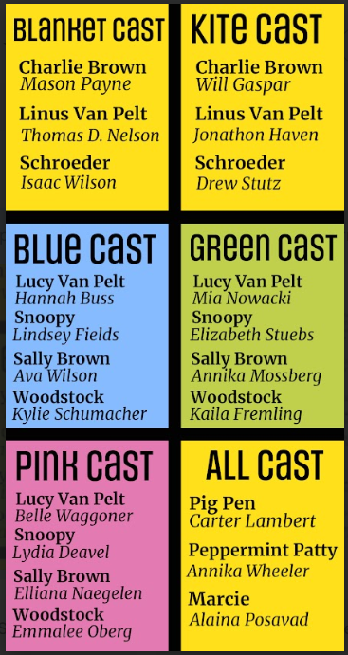
The other unique aspect of our production is that we simultaneously single, double, and triple casted the show. Due to the large amount of students we have, and the small ensemble nature of Charlie Brown, our director wanted to increase the opportunity for actors. The female roles of Snoopy, Lucy, and Sally became triple casted, and we added a non-verbal dance role of Woodstock that was also tripled. Linus, Schroeder, and Charlie Brown were all double casted. We included a single casted ensemble of three characters to build out the cast as well. This was a logistical hurdle like I’d never seen before. I had to develop a plan to make sure all combinations of casts were comfortable and familiar with each other, than all casts were getting roughly equal stage time, and try to balance many other aspects of fairness throughout the duration of the production. The production team devised the categories of Blanket and Kite for the men, and Pink, Green, and Blue for the women. This allowed to combine an object with a color to quickly and clearly get a single full cast of actors together. This is how we ran rehearsals and performances for the rest of the process.
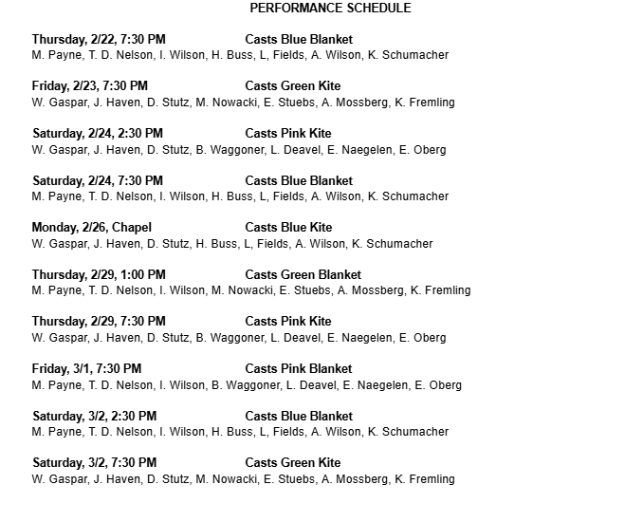
I had a stack of papers I would rotate through. Three B’s and three K’s, each a different color corresponding to a unique casting combination. Every scene we would switch a new combo in to make sure actors were getting reps fairly throughout the show. Eventually, we split the show into three parts, and started cycling that way. At the very end, a single combination would run the entire show. I made several iterations of a performance schedule to communicate to actors who would be on each night. This is the final schedule that was sent out to the actors. We did everything we could to fairly balance shows, and we ended up having all 6 unique combinations perform live together.
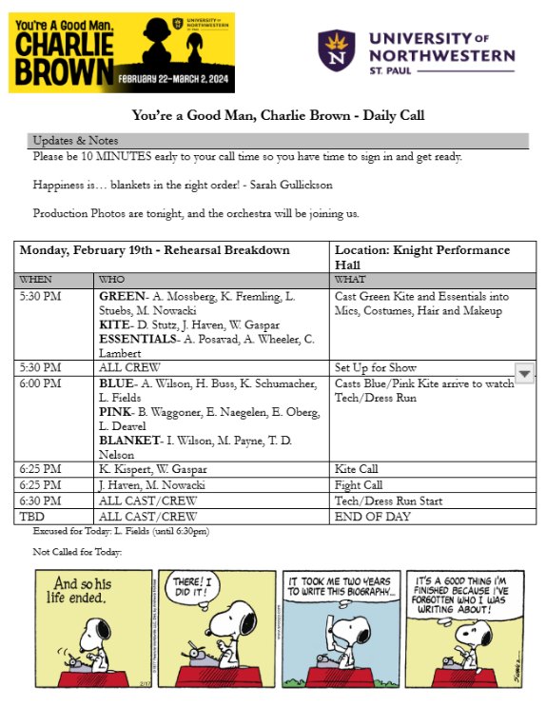
I was also responsible for the standard Stage Management documentation of reports and daily calls. I take a lot of pride in my calls- they are the documentation that is most widely viewed by the company as a whole. They should be neat, direct, and be sent out quickly. Most importantly, they must be correct. One of my ASM’s would usually write the rough draft of the call, and I would check it and add to it as necessary. Being specific about which casts were on in different moments became really important, so my calls looked like this for this production. I also added some “fun” into these calls by including a “Comic of the Day”, and in the notes section of each call I would have a company member tell me what “Happiness” was to them, in theme with the closing number of the show, “Happiness.” As serious as my job is, it is good to promote positive vibes throughout the cast.

ROMEO & JULIET
Stage Manager

Jennifer Hunter- Director
Iris Dodge- Technical Director

Produced by University of Northwestern St. Paul
September 2023
STAGE MANAGER
Romeo and Juliet marked my 1-year anniversary with Stage Managing. For me, this production was all about taking my skills to the next level. I had much more confidence in how to stage manage, and who I was as a stage manager.
I started working on the show during the summer before returning to school for the Fall Semester. It allowed me to do very detailed preshow work over the extended period of time. Me and my ASM’s split up some of the work and by the time rehearsals started, we were in great shape to lead the production. This was crucial for R&J, because we went from 1st rehearsal to opening night in just over 3 weeks. The entire cast and crew received this information almost immediately, because I prepared First Day Folders with this information.
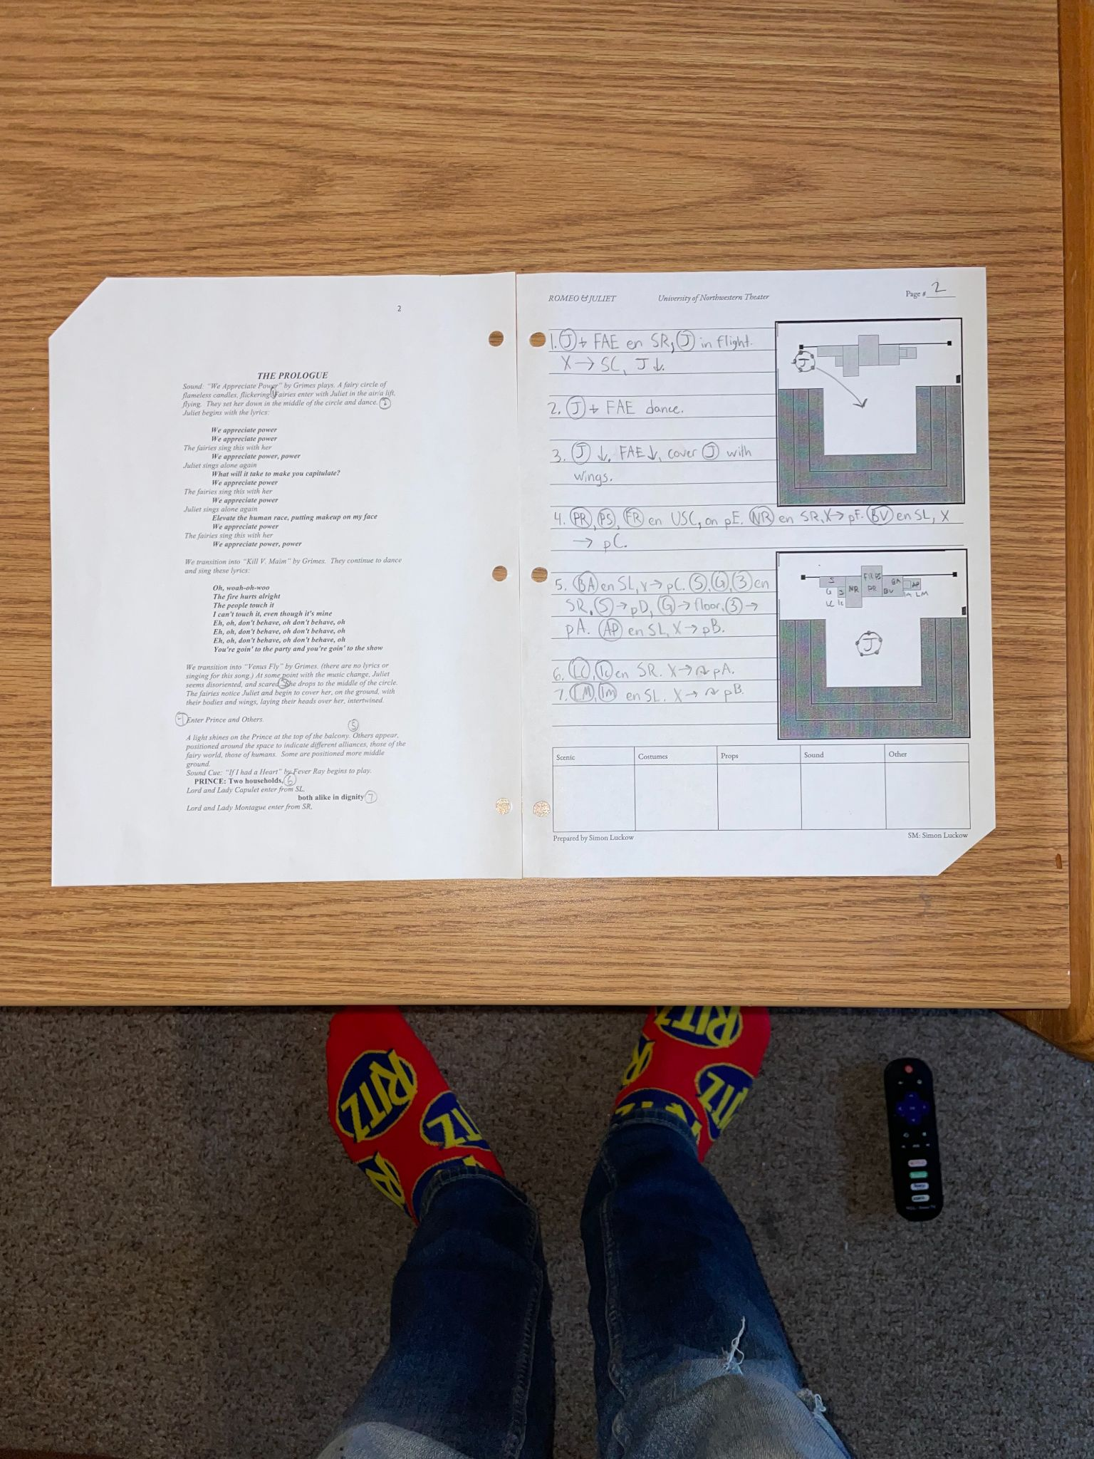
Rehearsals started with blocking, where I took blocking notation. I also noted any basic scenic, prop, costume, and sound notes I would want to have immediately accessible in my script.

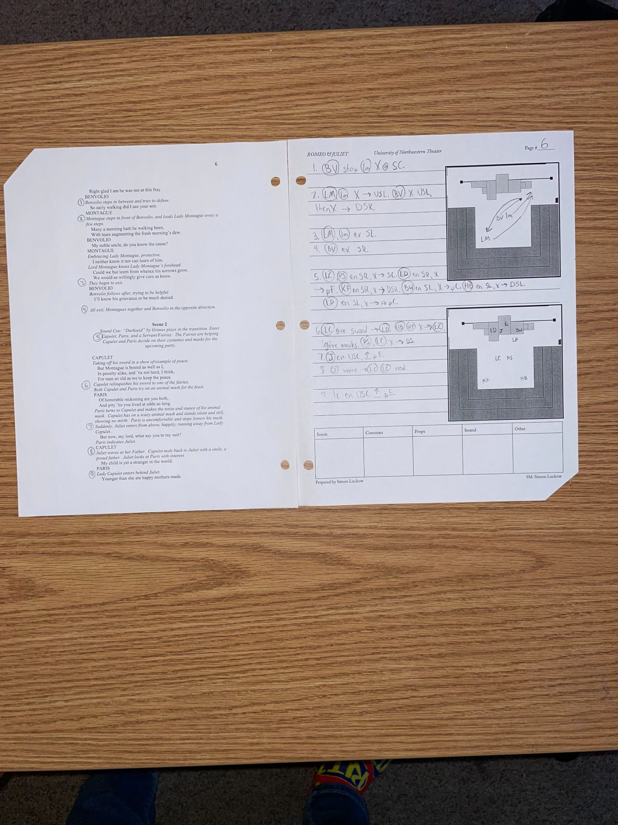

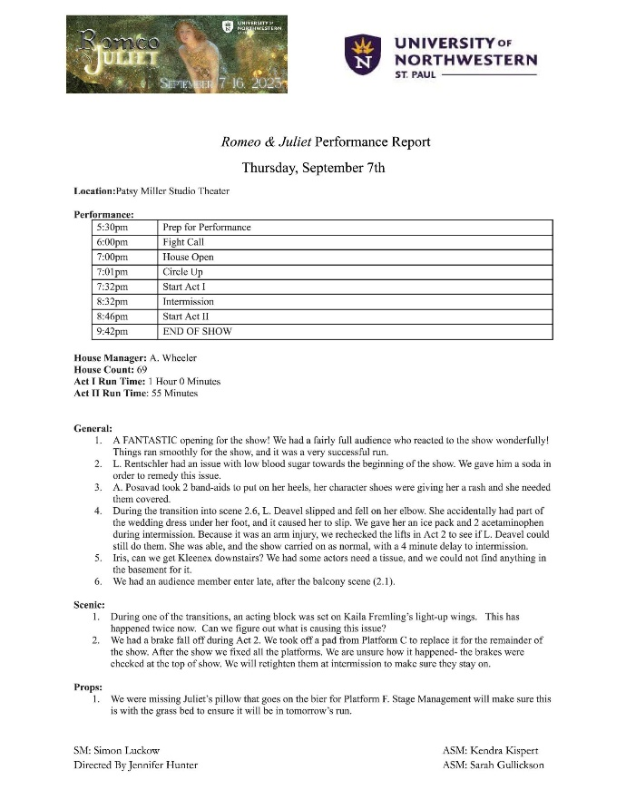
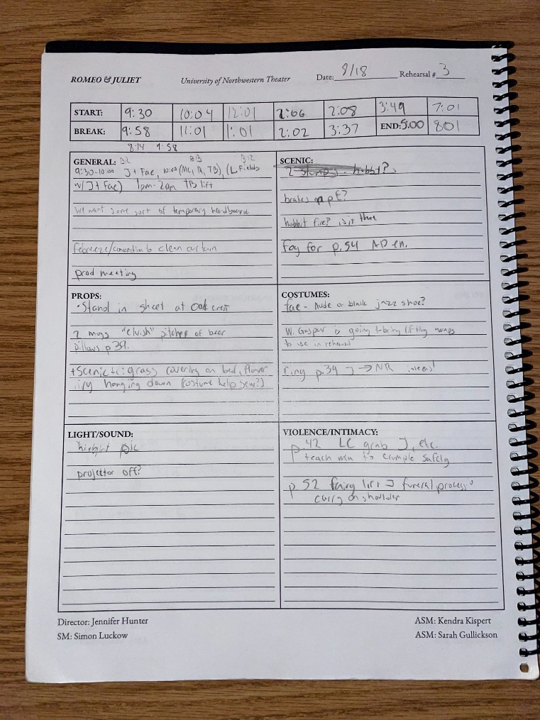
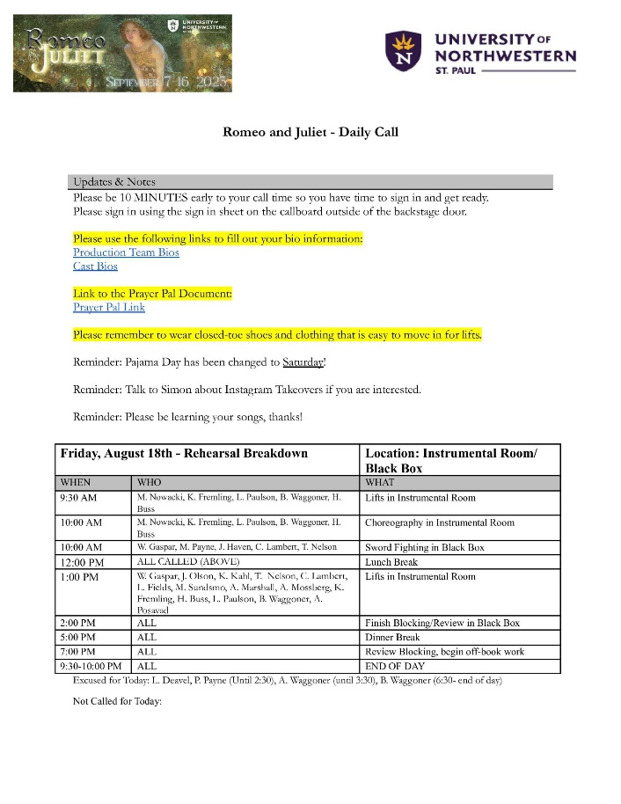
While these rehearsals would happen, we would also be running some dance rehearsals, lift rehearsals, and fight rehearsals where we could fit them in. The daily calls I sent out each day were very important to communicate the day’s information to the cast so they would know when they needed to be somewhere, and when they were expected to arrive. It saved lots of confusion since we were running multiple rehearsal rooms at the same time.

During rehearsals, the director would have lots of notes and suggestions for things she wanted to see happen. I would write anything like this down in my Log Book. This allowed me to retain all of this information and ensure it all made it into a report, a designer could take care of the note. I also logged start times, when we would take breaks, and when we would shift to different parts of rehearsal.

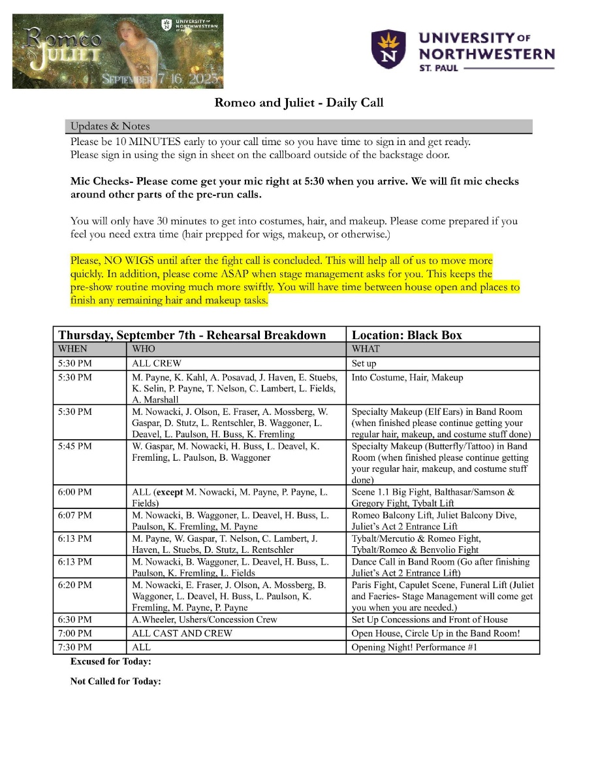
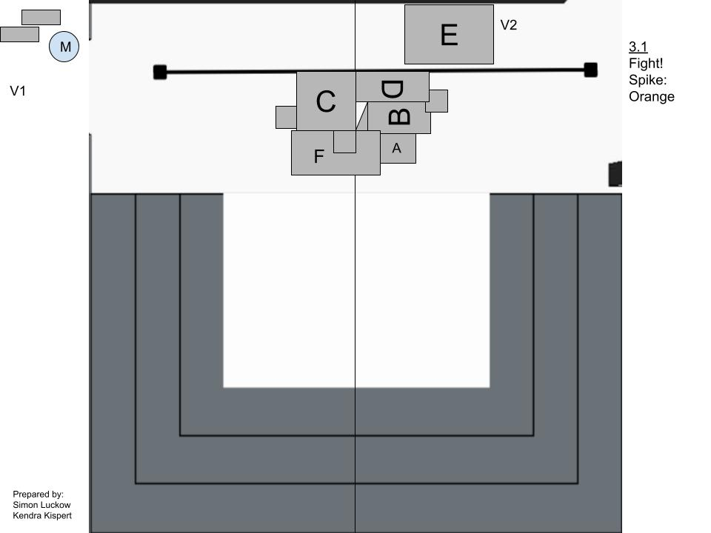
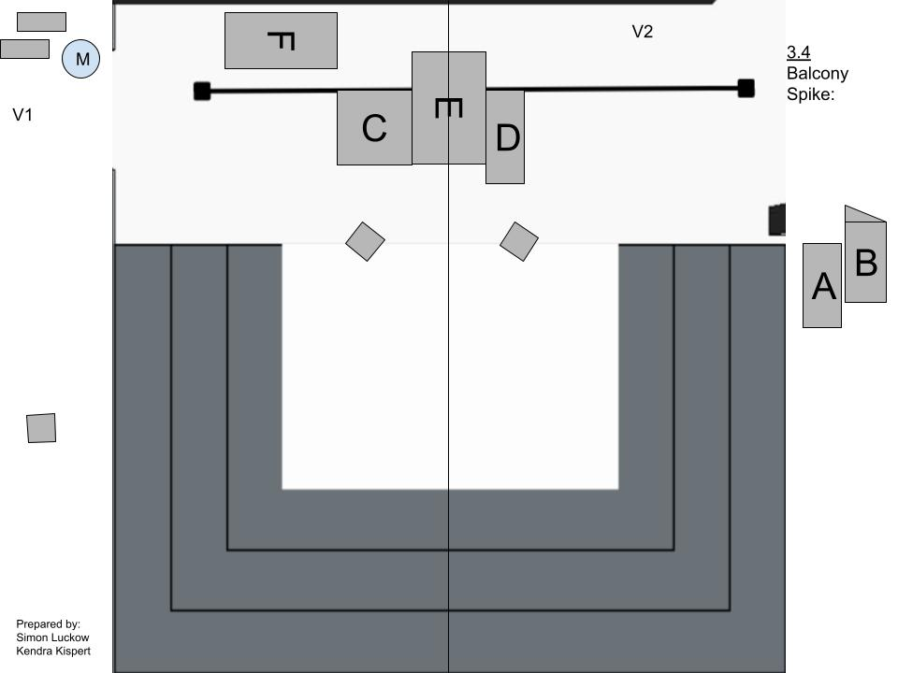
The majority of the scenic design for the show was 6 platforms of different shapes and sizes that let us create different picture for different scenes. Tracking the movement and landing places was difficult by itself, but it was also important that the cast who would actually be doing the transitions understood where things needed to be on stage. My solution to this was to create electronic scenic layouts to hang backstage that the actors could reference. This also let me give my director a copy of the layouts to help her visualize scenes that needed fixes and re-blocking.

Once we got to performances, my Daily Calls got very extensive and detailed. I had actors that needed specialty makeup, fight calls, dance calls, lift calls, mic checks, and more. I had to create a very detailed plan to get through all of these things quickly and efficiently, without wasting actors time.

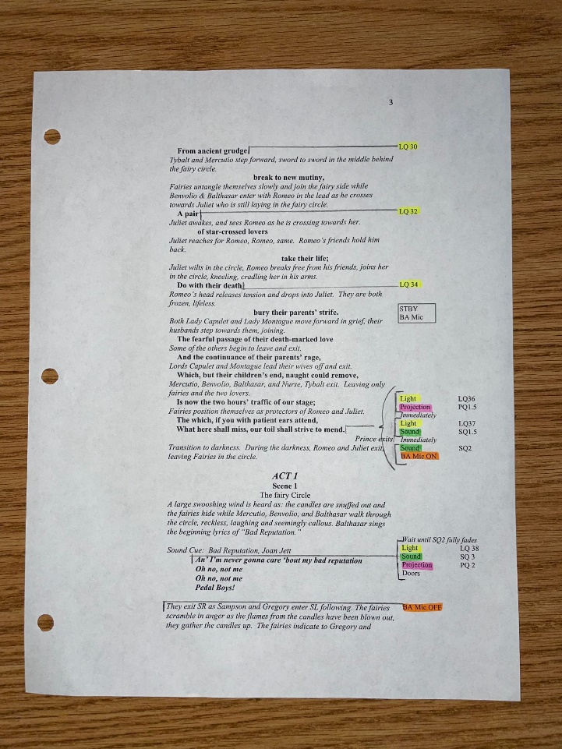
My calling script was also quite detailed. There were many types of cues- light, sound, projection, fog machines, entrances, and a few other random things too. In total, it was 420 cues. Lots of them relied on visual cues from actors, so I had to always note to myself when the correct time to call those cues were.
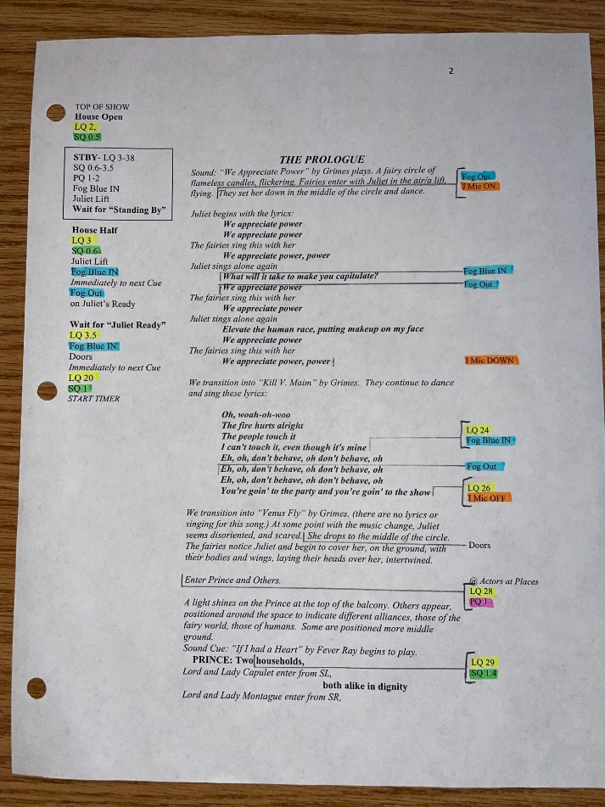
Visual cues were challenging at times due to the facilities I was working in for the production. This show was performed in our studio theater, which does not have a booth with a direct sightline with the stage. I called the show over monitors with 4 different camera angles of the space, and a direct audio feed of the space to hear the actors. Fortunately, there is no delay in the system, so I can keep up to speed with the actors. The real challenge is when I cannot see an actor particularly well, and have to learn their timing without necessarily watching. Fortunately I have called a few shows with this style and have learned how to do it well.

MUCH ADO ABOUT NOTHING
Stage Manager

Joseph Papke- Director
Dietrich Poppen- Technical Director

Produced by Classical Actors Ensemble
Summer 2023

STAGE MANAGER
This production was my first project outside of my university. With it came several new parts of the job that I had not previously been a part of. This was my first full length production as a one man team, so I had to figure out how to use my time in rehearsal more efficiently in order to get all of the information necessary down. I previously relied on ASM’s to be tracking most of the material that goes on runsheets while I focused on blocking/bigger picture things. That would not fly with this show.
Much Ado is the first show in a rented rehearsal space I have done as well. Part of my duties would be arriving early and setting the room, and then making myself available to be opening the doors for people to enter when they arrive.
Being the first time I was working with this company, I also had to learn how my director operated in his job. This director had a very different style of blocking and running the rehearsal than directors I previously worked with. I had to be flexible and on the fly in order to keep up. This production helped grow my confidence as a Stage Manager, proving to myself that I can keep it in an environment outside of my school.
The other unique aspect this production was it was performed as “Shakespeare in the Park.” Over the course of 19 performances, we performed in 16 parks. This meant we had to be mobile, simplistic, and efficient. I kept a large majority of the props in the trunk of my car for the duration of the show. We’d arrive 90 minutes prior to the performance, put up the set, and then actors would get into costume and get ready for the performance. Once the show was over at around sundown, we would quickly take it all down again and pack it away in peoples cars. This was very different for me as a stage manager. Due to the nature of the show, there were no cues to call or changes to facilitate. Things were minimalistic. My duties during the run itself were to watch our “backstage area” and do a count of the crowd.
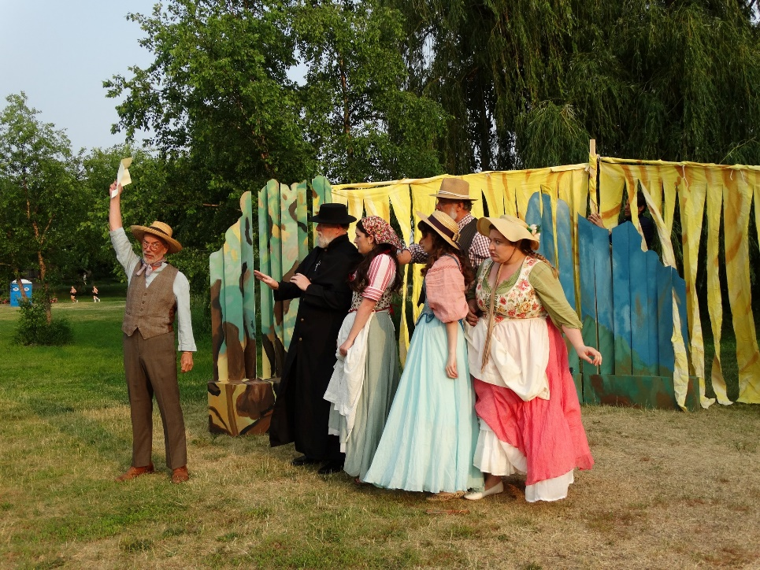

UNW ONE ACT FESTIVAL
Production Stage Manager

Jennifer Hunter- Class Supervisor
Iris Dodge- Technical Director

Produced by University of Northwestern St. Paul
May 2022

PRODUCTION STAGE MANAGER
This One Act Festival was a very different style of Stage Management than the shows I had done previous to this one. Instead of one large production, we were putting on 14 5-10 minute shows, in two separate performance groups. This festival employed a cast and crew of 56 members, plus 14 student directors. In addition, I was a one man SM team for the duration of the process. I was not hands on with any of the productions until the tech process, where we brought in all 14 shows to work through lights, sounds designs, scenic elements, and transitions between shows.
The biggest challenge to this festival was the number of people I had to communicate with and manage. Around half of the actors were brand new to theater at our university, and did not know how to operate beyond their experience is high school was like. They didn’t typically know how to read a daily call, and didn’t know a lot of the theatrical jargon that we use. I had to slow down, and be very accessible and reliable for these actors to ensure that they could fulfill their end of the production.
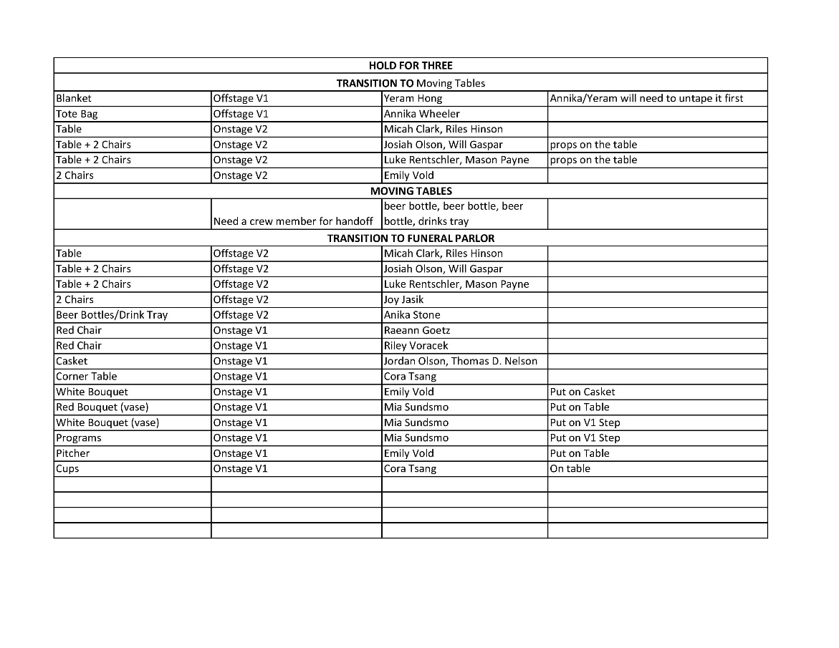
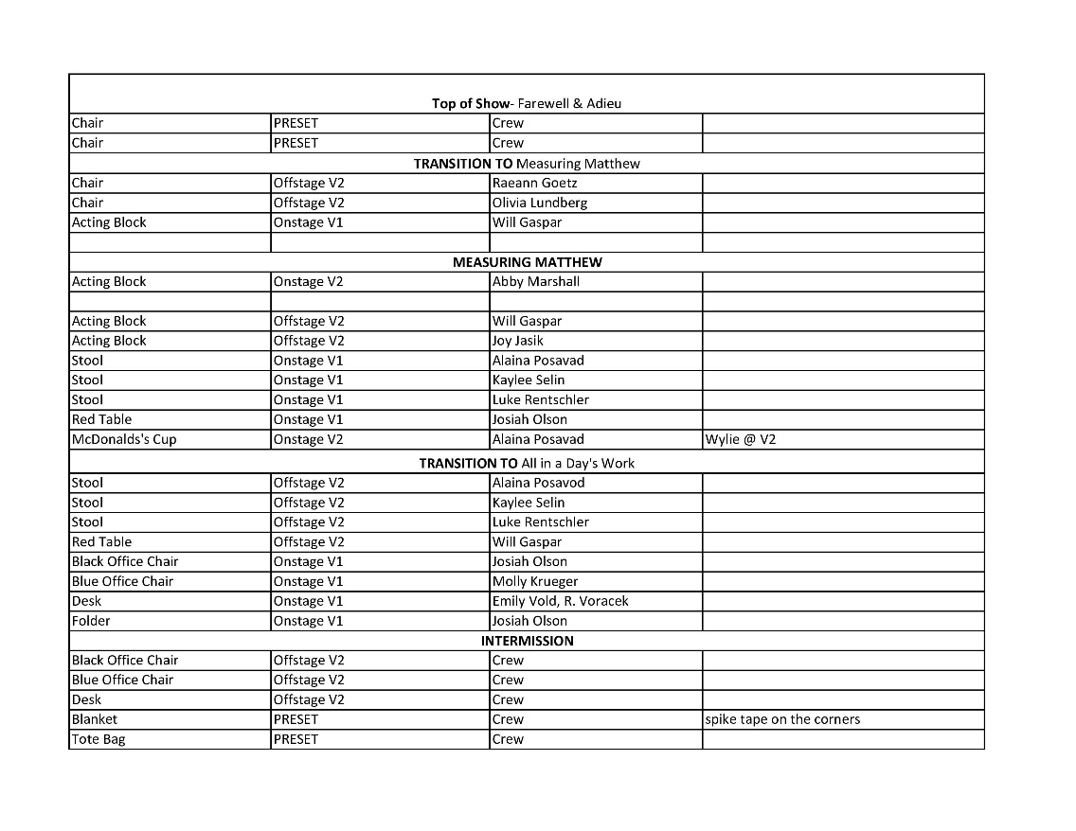
Logistically, figuring out scenic transitions and how to store pieces for 14 shows backstage became very complicated. I made a very simplified version of a scenic runsheet with only the necessary information for actors to reference with all of the transition information on it. I personally laid out the backstage area during my preshow to put things in an order that allowed for the most effective traffic patterns. It took some trial and error, and a few times for my actors to understand how things needed to work, but it all ended with a smooth festival with minimal problems.

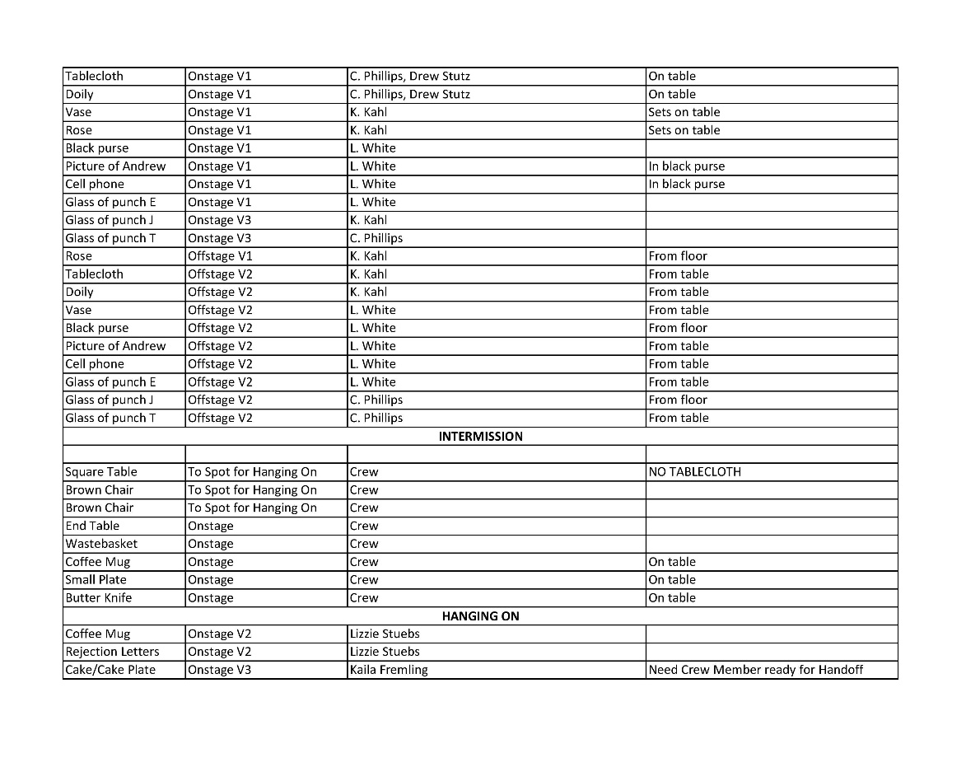
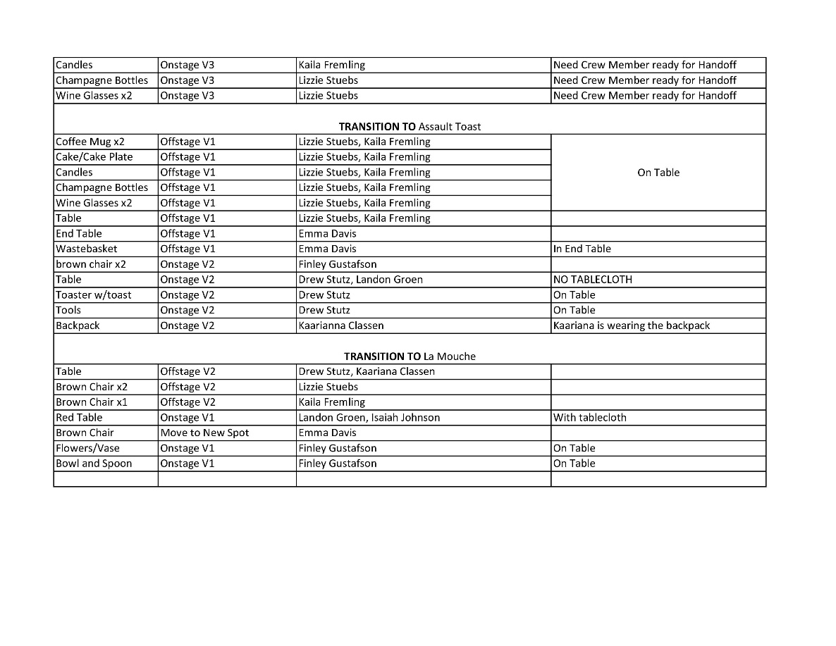
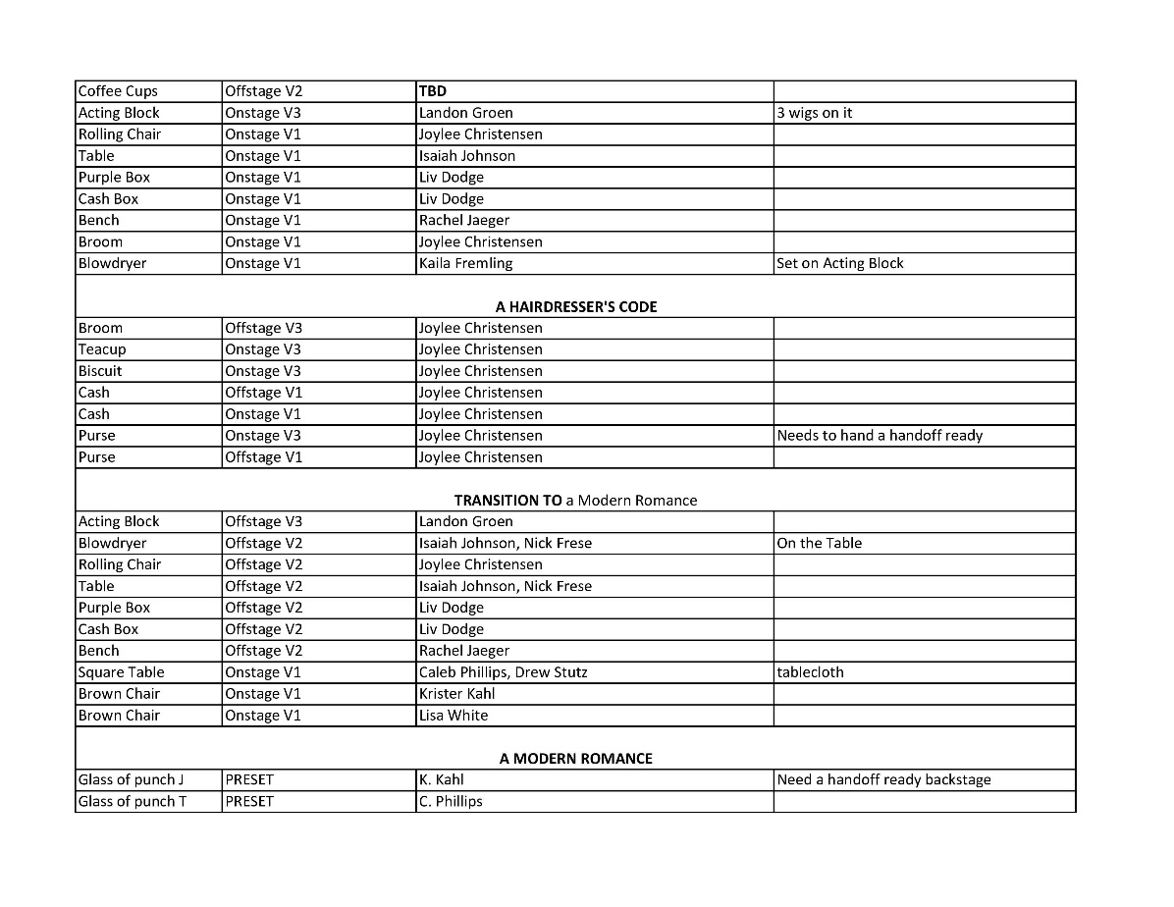
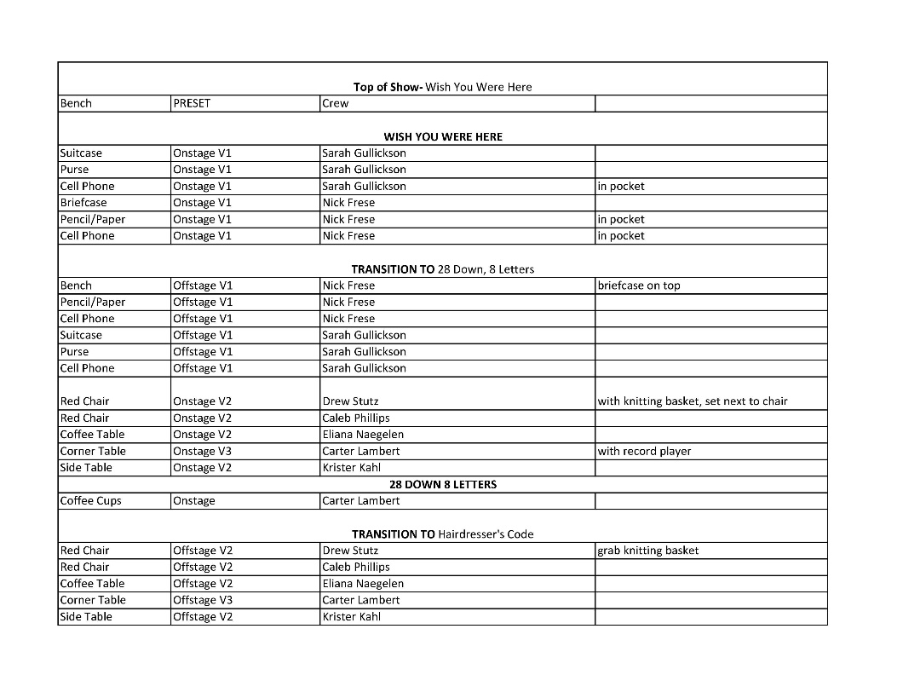
THESE SHINING LIVES
Stage Manager

Jennifer Hunter- Director
Iris Dodge- Technical Director

Produced by University of Northwestern St. Paul
September 2022

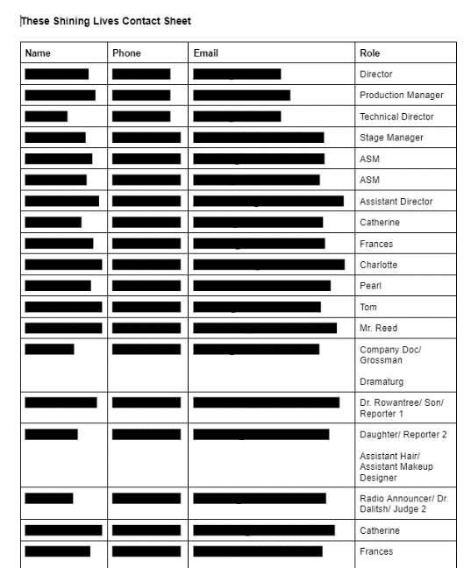
STAGE MANAGER
As the Stage Manager for These Shining Lives, I was heavily involved in every step of the process while putting on this show. I ran the auditions with my team, and then over the summer, me and my ASM’s did all of the necessary prep-work we needed to do before starting the rehearsal process in August. This included making conflict calendars, contact sheets, sending out scripts, doing production meetings, and many other things.
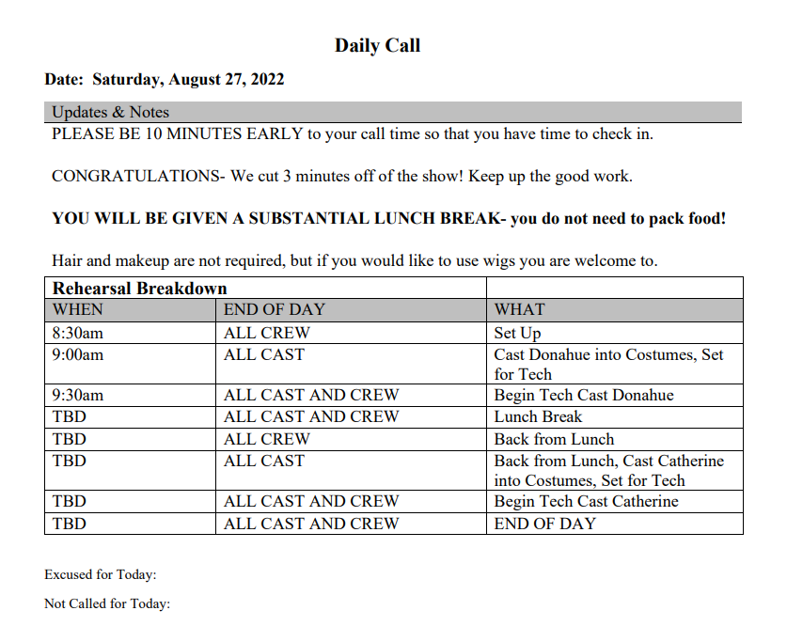

Once rehearsals started, I added a few duties to my plate. I made daily calls for the production and made rehearsal reports after each day concluded. I oversaw my ASM’s in making the scenic, costume, and props runsheets. I took blocking notes in my blocking script and took other notes in a logbook I had made. In cooperation with the director, I ran the rehearsal and ensures the production was coming together properly and assisted wherever problems occurred.

During tech, I got all the cues from the designers and began to call the show. This came with a whole new set of problems to figure out, but me and my ASM’s worked alongside the TD to get the show off of the ground and running.
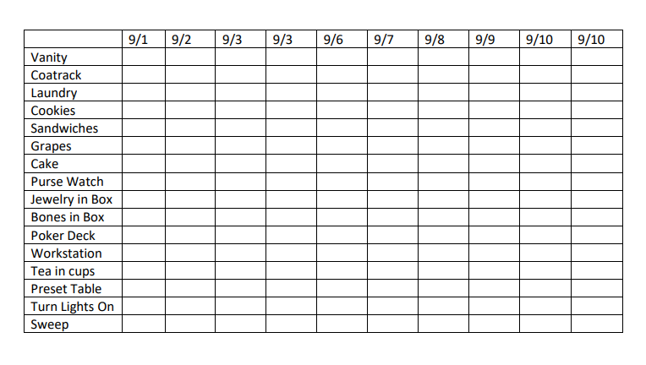
During the performances, I came to the theater, made sure the show was set up and ready to start, which included a specific preshow checklist, and then called the show. Once the show was over, my crew would reset for the next day while I did a performance report reviewing the events of that day’s show. If any other further communication was needed, I would do that too. I would finish my day by sending out the next day’s performance call.
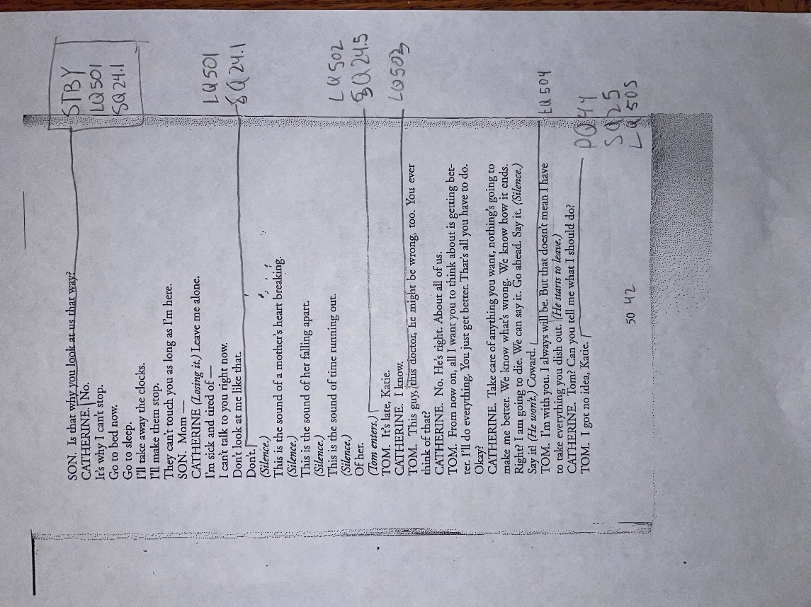
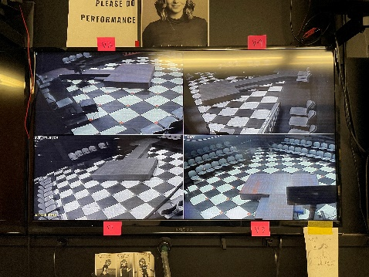
There were a few factors in the space we hosued our show in that provided challenges to my job as the SM. We housed These Shining Lives in our blackbox theater. It provided a nice intimate feeling to the show. However, our blackbox does not have a booth where an SM can see the space and hear the show live. Instead, the SM is in a room across the hall from the theater, with 4 cameras in each corner of the space and microphones feeding the sound into the “control room.” This was initially a challenge, but throughout the process I learned how to use the nuances of the room to call the show effectively.

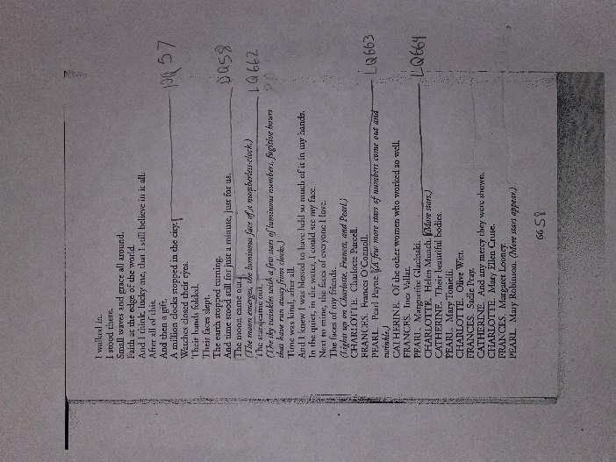
These are samples from my calling script for sequences of calls throughout the show.

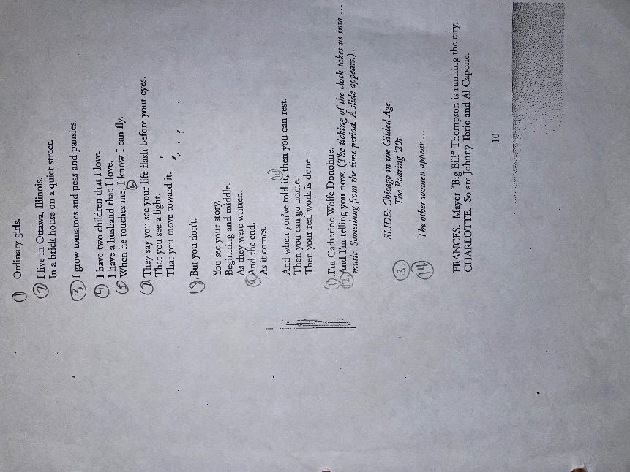
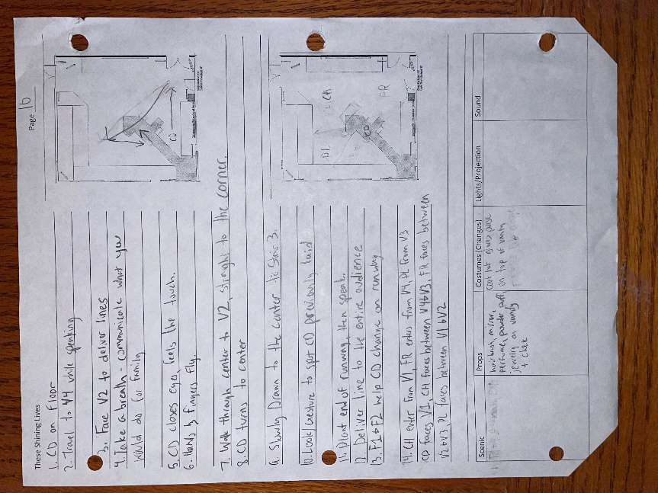
This is one of my blocking sheets from my blocking script. It has ground plans for me to draw diagrams or picture, lines for me to write out blocking, as well as spaces in the bottom to write needs for different technical areas.
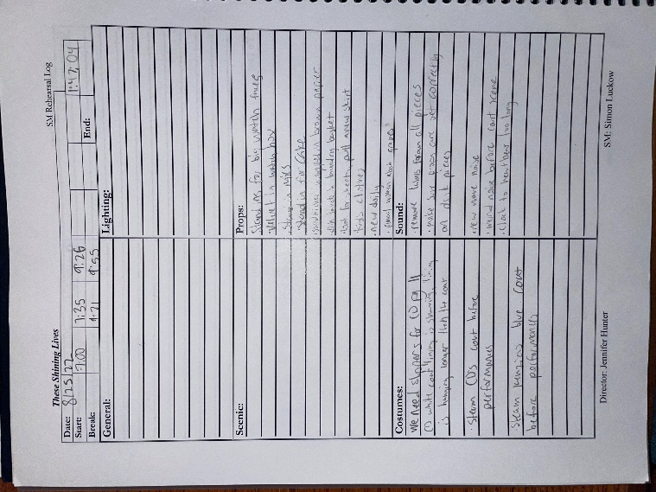
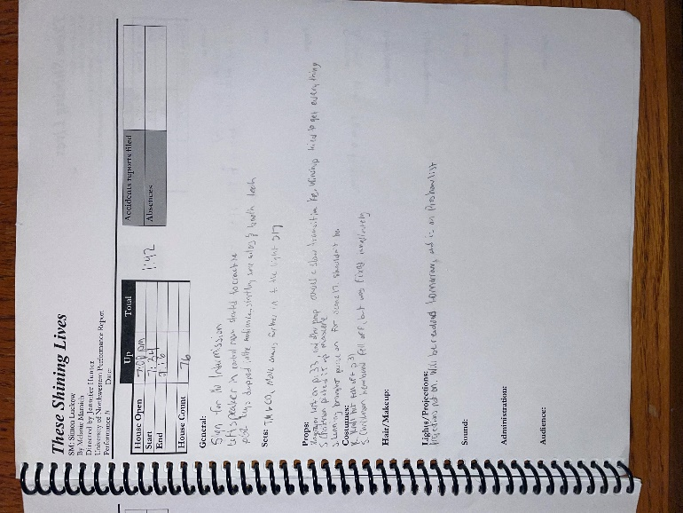
These are pages from my log book. They were used to monitor the shows development, and make any notes I needed to put into the daily rehearsal report.
Throughout the run of the show, I learned a lot about how I work as a Stage Manager. I have spent most of my theatrical career as an actor, and this was one of my first experiences on the technical side of a show. I think this heavily influenced my style of stage managing. I know the language of the actor. I understand how they think, speak, and work. I was then able to use my new identity of an SM to bridge the gap between the directors vision, and the actors understanding of it. I could take what a designer was saying and make it understood by the rest of company.
I decided very early in the process I wanted to lead with positivity and set a good energy for my cast. I think this aided our production in moments of stress and frustration, and allowed plenty of moments for fun, growth, and laughter as we mounted our show.
I also put my full energy into being punctual and prepared. I was the first one into the rehearsal room every day, and the last to leave. I made sure things were ready for the cast to come in, and made sure I left the day in good shape to be set up for the next. I wanted my cast to see that I was taking the show very seriously, which was another tone setter for the group. I lead by example, and my company followed that lead. I think that is the best way to lead. I don’t think it matters much what you tell people- you’ve got to show them.

LITTLE WOMEN
Assistant Stage Manager

Jennifer Hunter- Director
Grace Wright- Stage Manager

Produced by University of Northwestern St. Paul
November 2022

ASSISTANT STAGE MANAGER
My duties for this show at the beginning of the process involved lots of paperwork. I helped the SM run auditions, and was responsible for making copies of audition forms to be sent into the audition room. Once the show started, I did a costume breakdown of the show, that would later be turned into the costume runsheet. I helped make lists of characters and people in different scenes, and did the conflict calendar. I assisted the SM in any other paperwork she needed help with, including Daily Calls. I also made many copies of script sections, as our direction was also the playwright, and we were making frequent cuts and edits that we would print off for actors.
Once I started being backstage, I often ran music off of my computer for transitions and dances, as well as start to figure out what costumes would need to be preset and moved around during the show, and how that would happen. When we started teching the show, I worked with my costume crew to make sure that all of the actors had the clothes they needed, knew when to change, and if they needed quick changes, had both the clothes to change into and the people to help them do it. I would float around backstage to all of the different spots where changes were going on to make sure they all went well. I also helped make sure the show would run smoothly alongside the other 2 ASM’s. Duties for the performances were nearly identical.
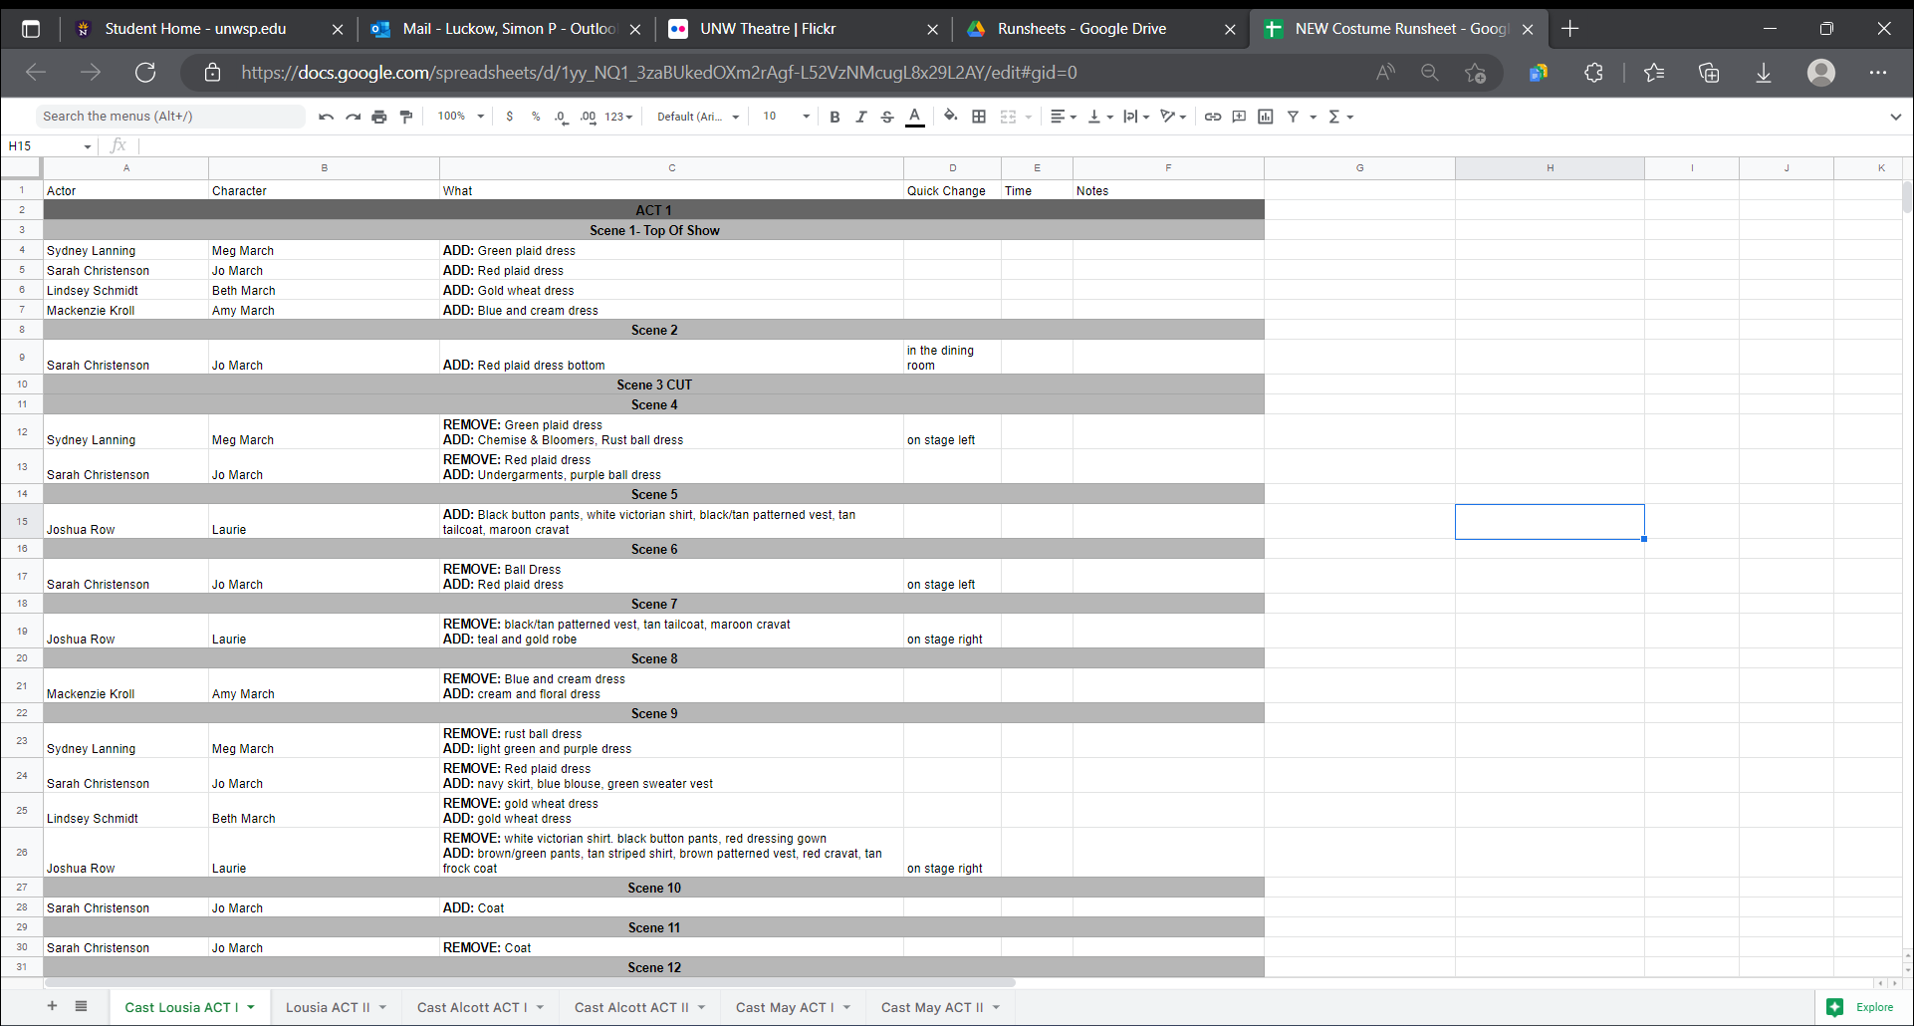

TWELFTH NIGHT
Assistant Stage Manager

Daniel McLaughlin- Director
Annika Mossberg- Stage Manager

Produced by University of Northwestern St. Paul
April 2022

ASSISTANT STAGE MANAGER
My main role on the SM team was to be the Scenic ASM. This meant I was in charge of all the scenic elements of the show, all the set pieces, and ensuring scene transitions ran smoothly. I made up a run sheet for the show of all of the scenes with page numbers, giving cue lines, transition assignments, where they were coming from and where they were going, and what color spike tape marks they were looking for. I communicated with actors backstage about their assignments and ensured they knew what they were responsible for and made sure they felt confident about their assignments. Once our show was running, I was in charge of leading a crew in presetting the set pieces before each act, and then I stood backstage and held doors open for the actors doing the transitions. I was also available to actors if they had any problems or questions, such as a broken shoe or they were missing a prop. After the show each night, I made sure the backstage area was clean and organized, everything was put away including the weapons, and that everything would be ready for the next day’s show.

This is a picture of the runsheet I created for the scenic elements in the show.
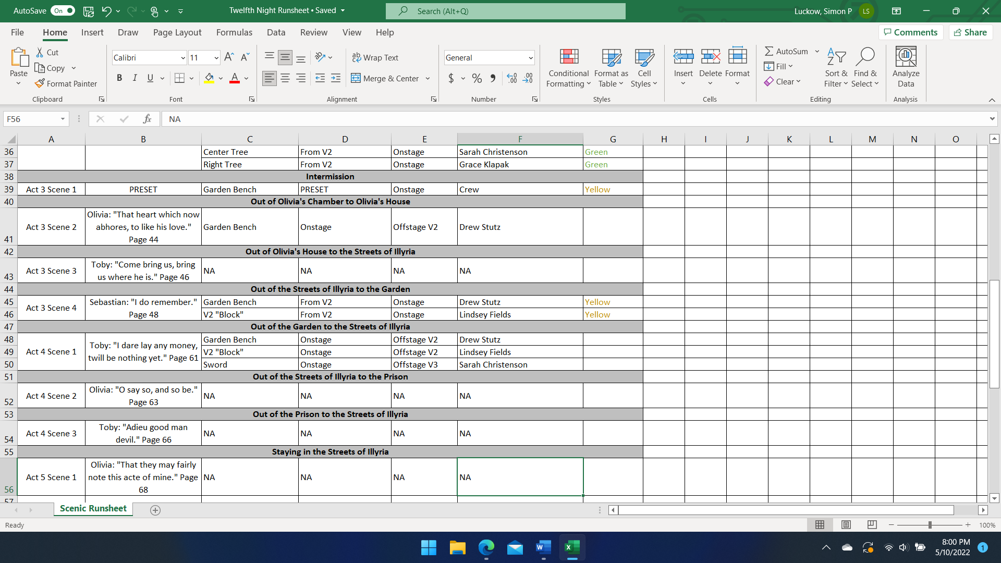

PROPS TECHNICIAN

ANYTHING GOES
Props Technician

Jennifer Hunter- Director
Iris Dodge- Technical Director
Alita Robertson- Props Mistress

Produced by University of Northwestern St. Paul
March 2023

PROPS TECHNICIAN
I was a props technician for Anything Goes. The first thing we did is met with our props designer to make a props breakdown for the show. We covered any kind of prop we would need, and created the necessary paperwork to document it.
Once the breakdown was completed, we headed to the prop shop in order to pull anything we had in storage. We were able to pull a large majority of our props from the shop. There were a few props, especially the paper props, that required building, so we tackled those next.
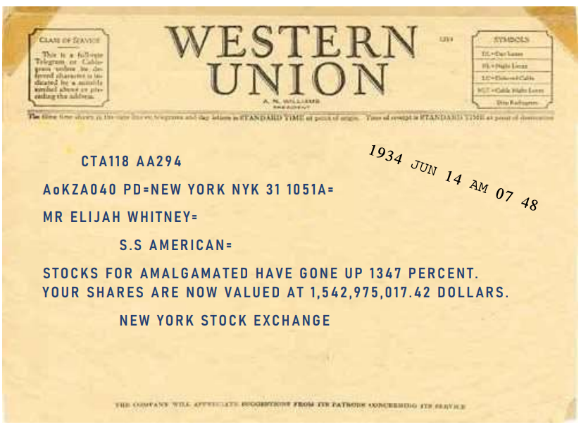
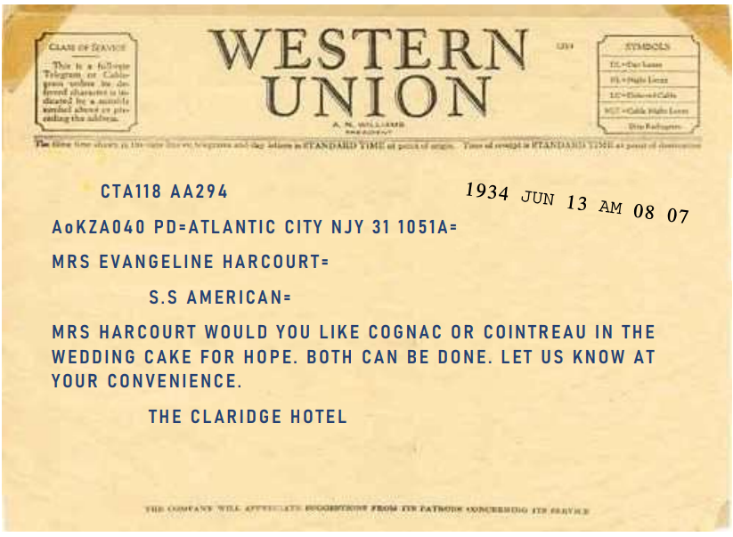
I built the props for the telegrams. I found a picture of a blank Western Union telegram and used that as the base of the prop. I then found a font that matched closely to the look of an original telegram and started using text boxes in order to make a very realistic looking telegram for the show.

I also helped cut and put together banners of flags that were used as decoration on the ship, and painting some life preservers that were displayed on the ship as well.

THE HOBBIT
Props Technician

Megan Liesmaki- Director
Iris Dodge- Technical Director
Belle Waggoner- Props Mistress

Produced by University of Northwestern St. Paul
April 2023

PROPS TECHNICIAN
I was a props technician for The Hobbit. The first thing we did is met with our props designer to make a props breakdown for the show. We covered any kind of prop we would need and created the necessary paperwork to document it.

Once the breakdown was completed, we headed to the prop shop in order to pull anything we had in storage. We were able to pull a large majority of our props from the shop. The Hobbit requires a lot of food props, so one of our biggest priorities was getting enough fake food to fill the scene so we wouldn’t have to use much real food. We also needed to pull other props to fill the world of Middle Earth, including weapons, maps, and other random things.

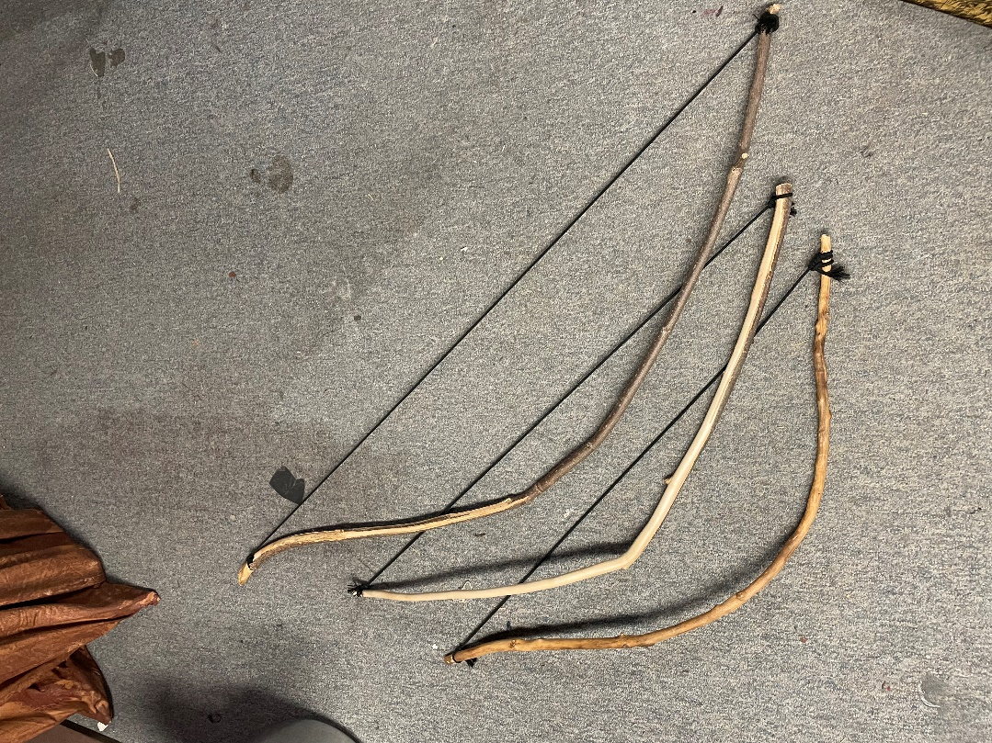
There were a few props that required some building. The elves needed to have wooden bow and arrows. While they did not need to be functional, they needed to appear like they could be. I found sticks outside and whittled them down to get them into bow shape. Then I used tie-line to add a string to make them look as real as we could get them.

SOUND TECHNICIAN

A CHRISTMAS CAROL
Sound Technician

Daniel McLaughlin- Director
Iris Dodge- Technical Director
Zach Morse- Sound Designer

Produced by University of Northwestern St. Paul
December 2022

SOUND TECHNICIAN
For this production, I assisted the sound designer in the finding of various sound effects to be put into the QLab for the show. I would find sound files and put them into a shared dropbox where the designer could approve sounds and incorporate into the design. Many of the sounds I found are displayed here.

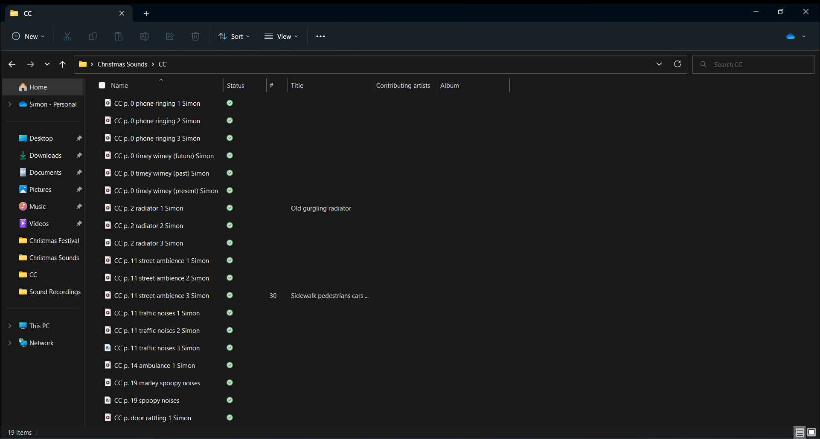

LITTLE WOMEN
Sound Technician

Jennifer Hunter- Director
Iris Dodge- Technical Director
Grace Wright- Stage Manager

Produced by University of Northwestern St. Paul
November 2022

SOUND TECHNICIAN
Me and 3 other students were collectively in charge of designing the sound effects for our production of Little Women. We all worked together to break down the script, and then find all of the sound effects that the show required. We found many options for each sound, and then met with our director and had her pick which options she liked best. After that, we would put those files into the QLab, where they could be edited and sequenced for the show.
I assisted in the editing and ordering of cues in the QLab, putting many of the cues in there myself. I would then clip the cues to the proper length, and set preliminary levels so they would be ready to be modified in tech.
One other aspect I took charge of was Voiceovers. We had many uses for voice overs during this show. I would have actors meet with me and record lines or other effects as needed into my microphone, and then I would put those into the QLab just like the other sound effects. Some of the voiceover moments required very specific sequencing, for example, when Amy falls through the ice. I had recorded 3 separate voiceovers that all needed to hit in a specific timing, alongside other sound effects. I built the sequence in QLab and made sure it worked properly.

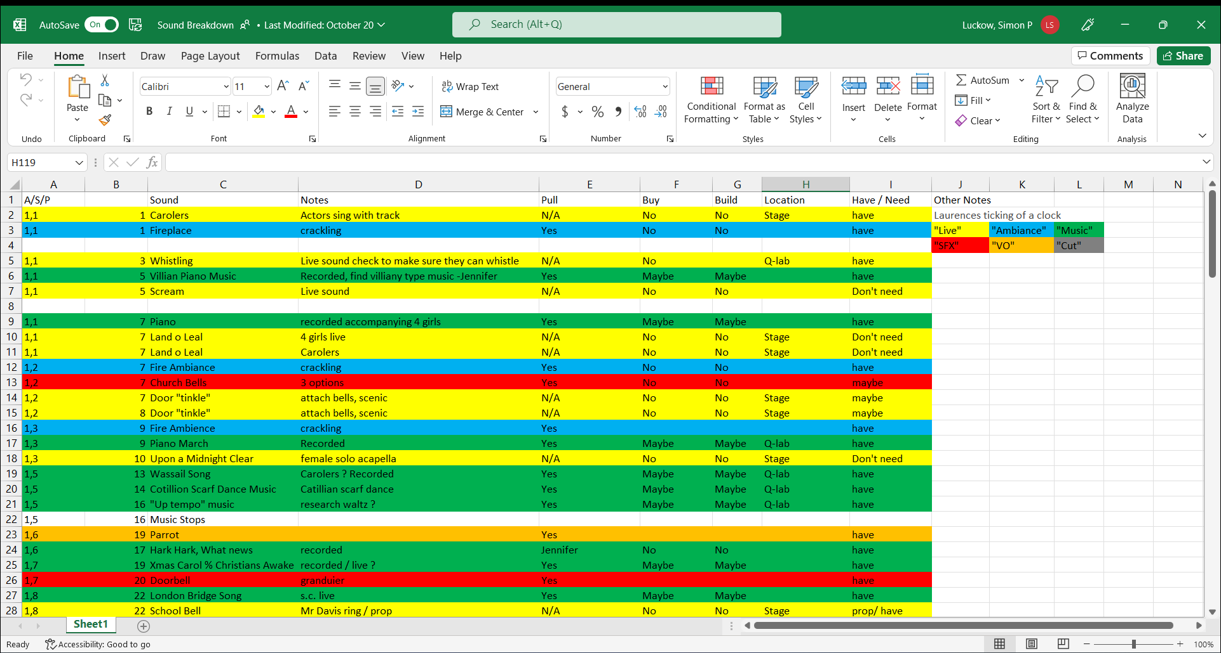

SCENIC TECHNICIAN

TWELFTH NIGHT
Scenic Technician

Daniel McLaughlin- Director
Iris Dodge- Technical Director

Produced by University of Northwestern St. Paul
April 2022

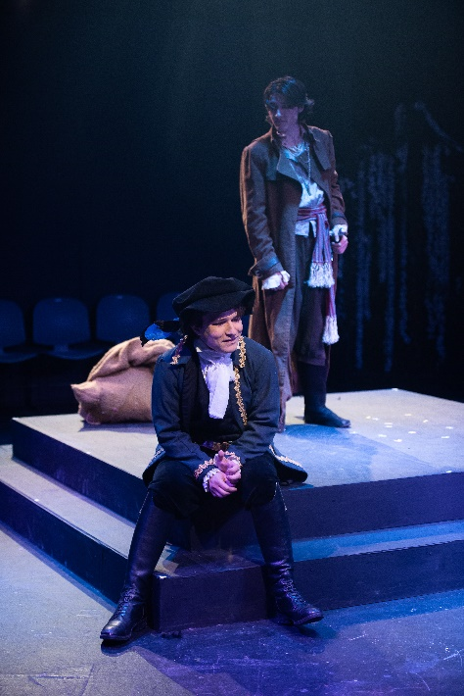
SCENIC TECHNICIAN

As a scenic technician for Twelfth Night, the most important thing I did was help in the construction of our main center platform. I measured and cut the legs for the platform, helped attack the legs to the 4x8’s, and helped build the stair units that went along with it.

Photo Credit: Twin Cities Headshots


Another thing that I built was a special set piece composed of three trees, with vines and flowers attached to provide cover for the actors using. This had to be designed in a way that allowed the actors to make themselves seen, but also to be completely hidden when they needed to be. I did this by draping vines over branches of the trees to make a curtain of sorts, that could be pulled back to reveal their faces when they had dialogue in the scene. I used flowers and other greenery to cover the wicker basket bases the trees were in to make it look a little more realistic.
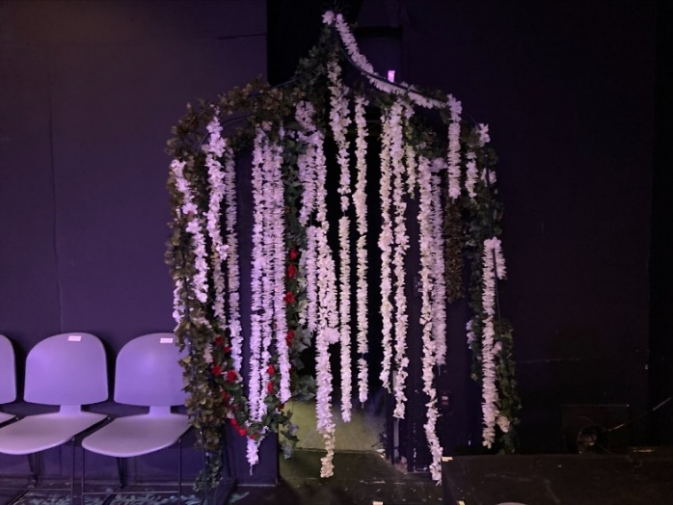
One other thing I built for the show was an archway that served as an “entrance” for one of the voms in the blackbox. It had both aesthetic and functional purpose. Aesthetically, it was themed after Olivia and a floral vibe, with vines and wisteria flowers draped down and around the structure of the arch. The functional purpose of it was to hide the actual exit into our backstage area, as the flowers and vines made a curtain that blocked the audience’s view.

THE LIGHTNING THIEF: THE PERCY JACKSON MUSICAL
Scenic Technician

Jennifer Hunter- Director
Iris Dodge- Technical Director

Produced by University of Northwestern St. Paul
February 2022

SCENIC TECHNICIAN
As a scenic technician for The Lightning Thief, I spent a lot of time over in the scene shop preparing set pieces that were being built for the show. I built a rolling cart that was used in the show as a “tractor” for the actors. We also painted many things for the show to match the set. I also helped put together a campfire set piece.
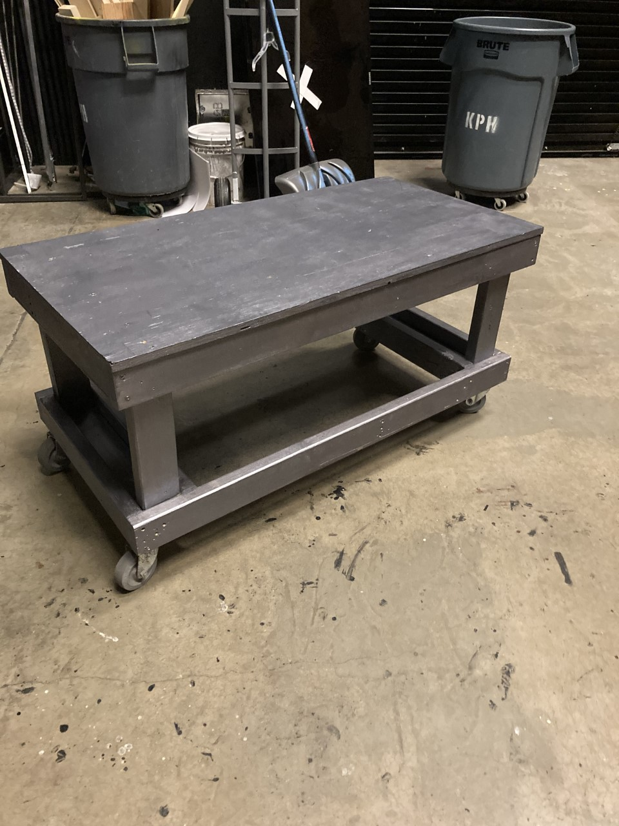

COSTUME TECHNICIAN

RAMONA QUIMBY
Costume Technician

Tommy McCarthy- Director
Jaylin Schumacher- Costume Designer

Produced by University of Northwestern St. Paul
December 2021

COSTUME TECHNICIAN
During the time the rehearsal process and run of shows of Ramona Quimby was happening, I worked in the costume shop and did whatever Jaylin, the student designer, needed me to do. I pulled many of the costumes used during the show from our basement storage. I also did a lot of costume maintenance, mostly steaming costumes that had been wrinkled.
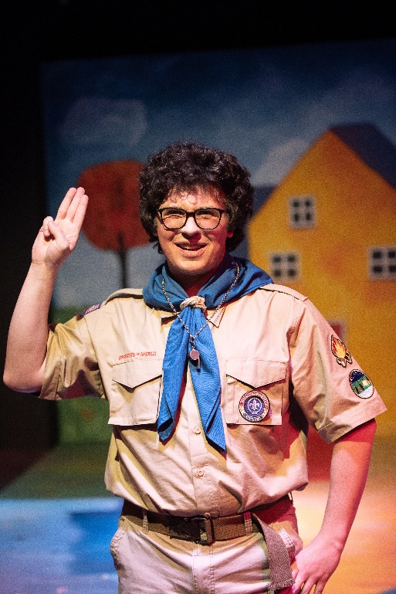
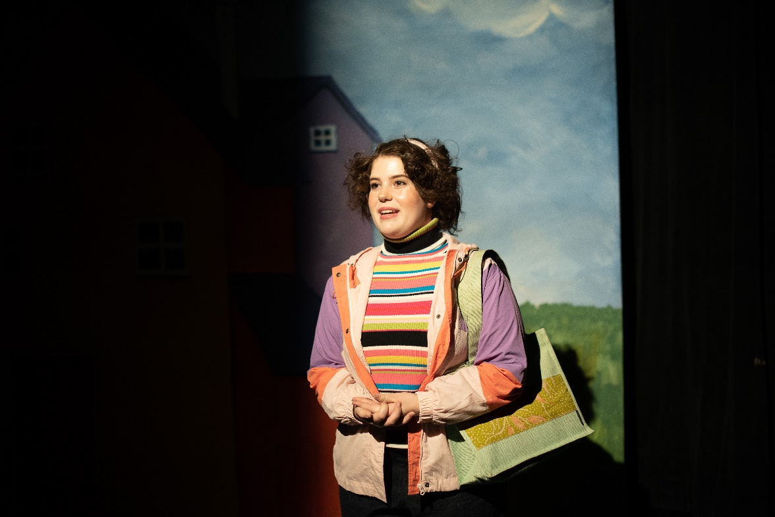
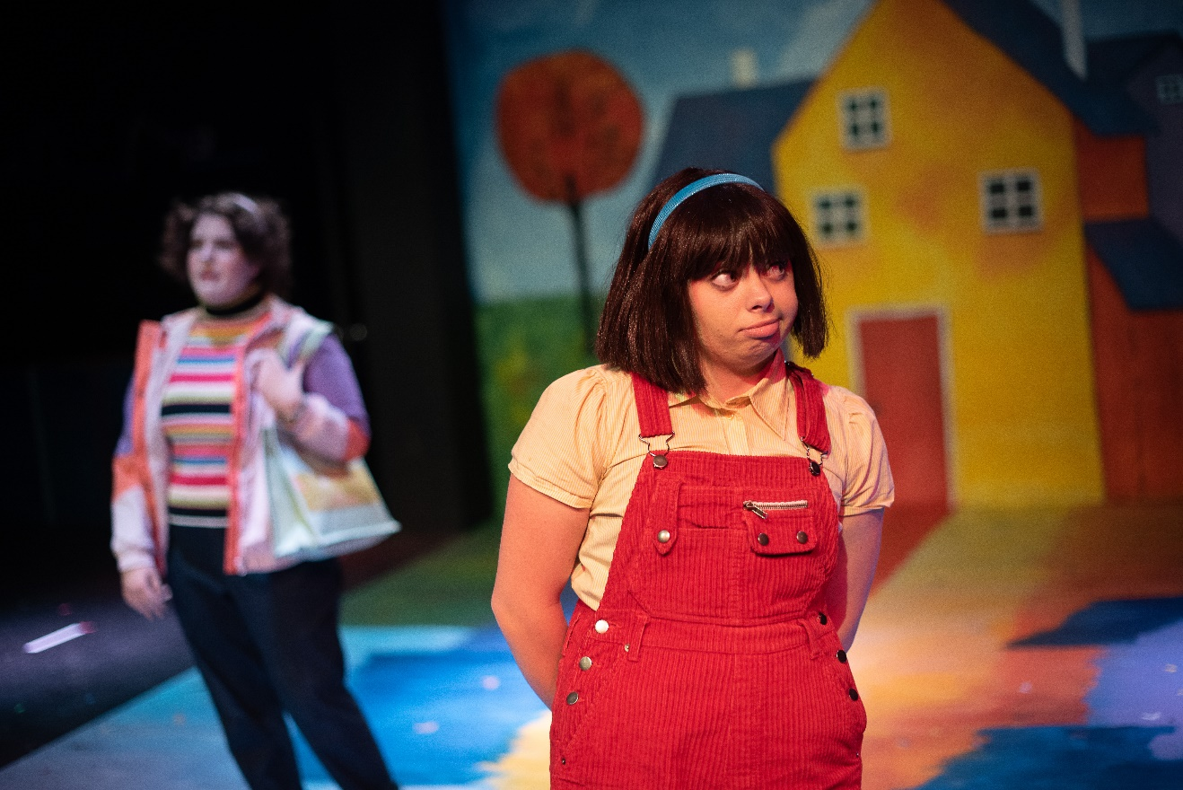
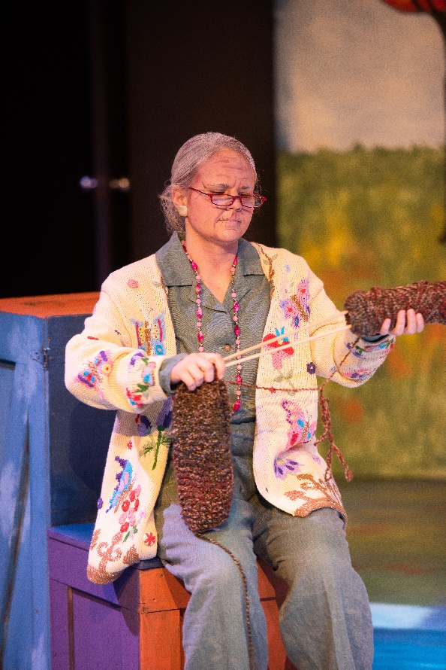
Photo Credit:
Twin Cities
Headshots
PETER PAN: A MUSICAL ADVENTURE
Costume Technician

Jennifer Hunter- Director
Sarah Christenson- Costume Designer

Produced by University of Northwestern St. Paul
Fall 2021

COSTUME TECHNICIAN
During the time the rehearsal process and run of shows of Pan was happening, I worked in the costume shop and did whatever Sarah, the student designer, needed me to do. I pulled many of the costumes used during the show from our basement storage. I also did a lot of costume maintenance, mostly steaming costumes that had been wrinkled, and hanging up costumes in dressing rooms after they had been cleaned. Once Pan had closed, I also helped to put costumes back in storage in their proper places.
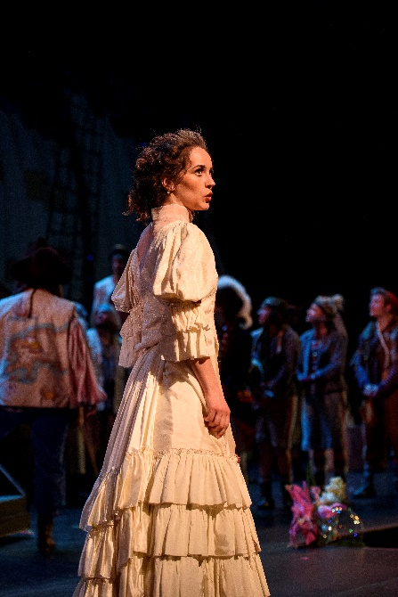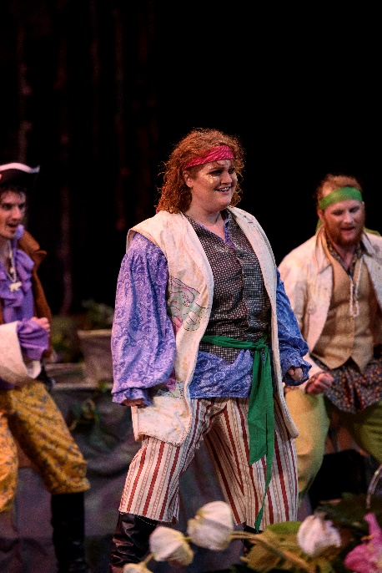

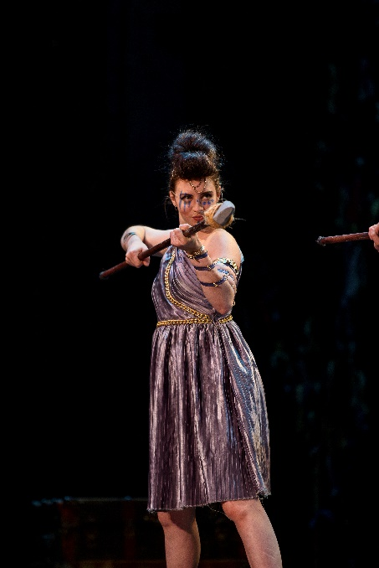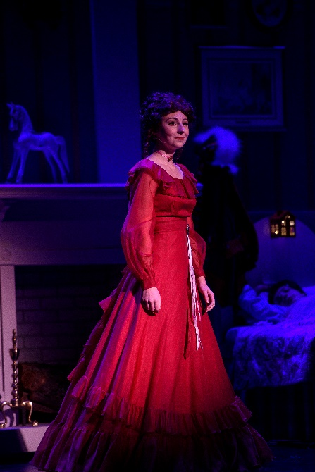
Photo Credit: Twin Cities Headshots

MISCELLANEOUS
POSITIONS

RAMONA QUIMBY
Sound Board Technician

Iris Dodge- Technical Director
Annika Mossberg- Stage Manager

Produced by University of Northwestern St. Paul
December 2021

SOUND BOARD TECHNICIAN
As sound board technician, I used QLab to run the sound cues for the production. The simple part of the job was playing the cues when the Stage Manager, Annika Mossberg, gave me the Go.
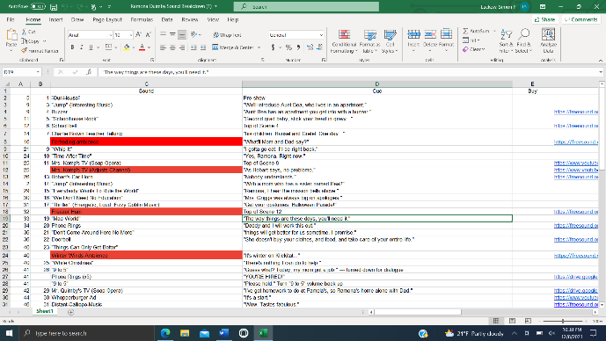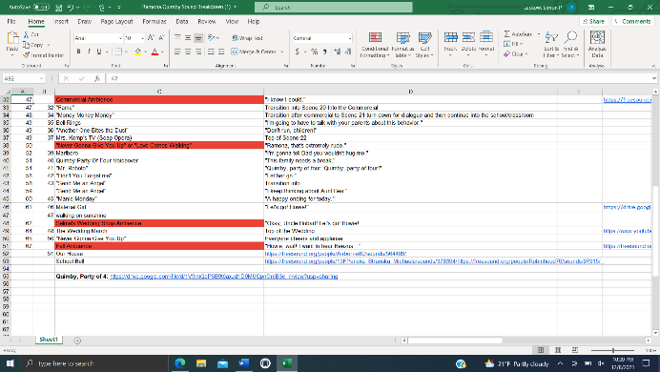

The parts of the job that were a bit more complicated were reordering, editing, and adjusting the levels of the different cues. Throughout the tech rehearsals we had a lot of notes on those areas. It was my responsibility to get the cues in the order the director needed them, and then to adjust the length of cues and the volume they were played. Many cues required grouping, which required some reprogramming which was also a part of my job.

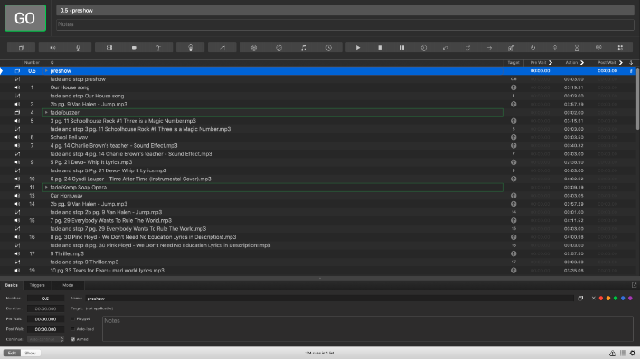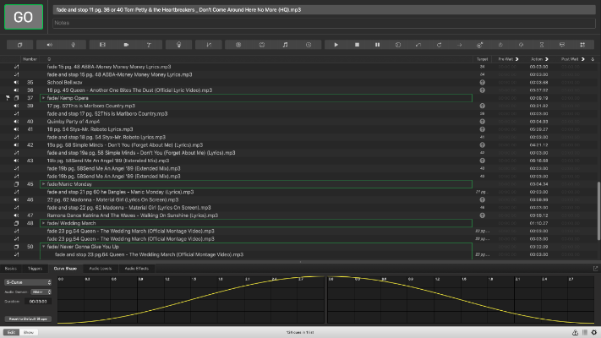

RAMONA QUIMBY
Hair and Makeup Assistant

Tommy McCarthy- Director
Gabrielle Fraser- Hair & Makeup Designer

Produced by University of Northwestern St. Paul
December 2021

HAIR AND MAKEUP ASSISSTANT
While working as the assistant for Hair and Makeup, I helped the head designer do research on typical 80’s styles to take as inspiration for the characters of Ramona Quimby. We then took that research and made a spreadsheet for the actors with instructions for their specific looks, as well as example pictures to follow.
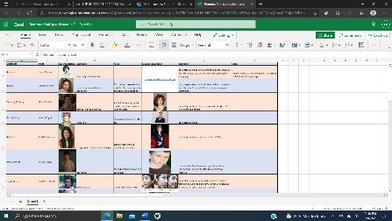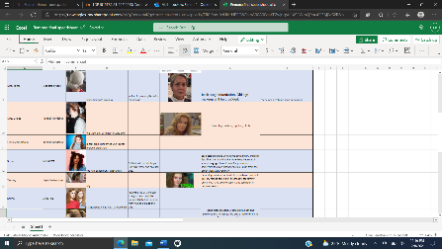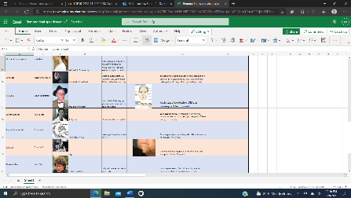
In order to make sure some of our ideas would work for the actors, I served as a model for the designer to test different methods of application for the makeup, as well as letting her get practice in before putting on the actors in the show. Once it was time for the actual actors to get the looks put on, I also assisted the head designer in doing the old age makeup looks, including the face aging and adding white and gray into the hair of the actors.
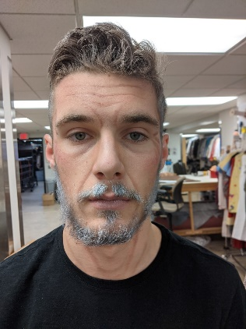 Photo Credit: Gabrielle Fraser 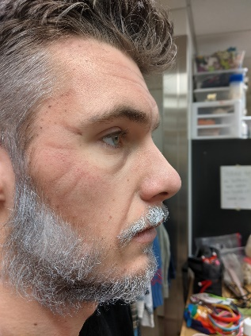

The other large design piece I did was building headbands for 2 of the wigs. We had headbands that needed to be covered by fabric. I cut the fabric out and glued it onto the headband to create a completely different looking headband.

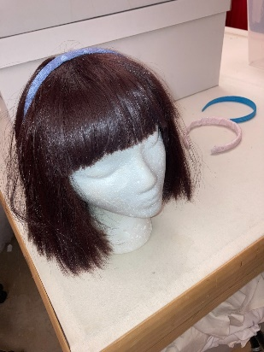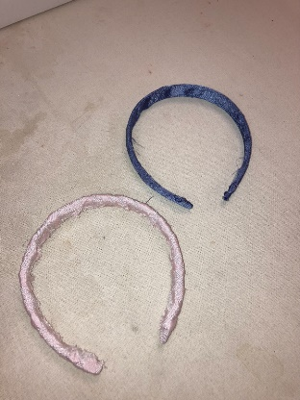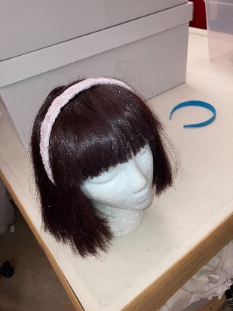

REFERENCES

JENNIFER HUNTER
Artistic Director and Professor of Theater at the University of Northwestern, St. Paul
jkhunter@unwsp.edu
(616) 340-9606

IRIS DODGE
Technical Director at the University of Northwestern, St. Paul
iddodge@unwsp.edu
(715) 360-0547

TIM MILLER
Manager at Knight Performance Hall, University of Northwestern, St. Paul
tjmiller@unwsp.edu
(651) 755-7242

COMPLETE
WORKS

Hershel and the Hanukah Goblins – Stage Manager
Directed by Hannah MacKenzie-Margulies ziessel@gmail.com
The Cat in the Hat - Cat
Directed by Mitch Geiken mitchell.geiken@gmail.com
Holiday Inn – Stage Manager
Directed by Jennifer Hunter jkhunter@unwsp.edu
The Night Witches – Stage Manager
Directed by Jennifer Hunter jkhunter@unwsp.edu
A Year with Frog and Toad KIDS – Assistant Stage Manager
Directed by Ella Williams ella@morningsidetheatre.org
Winnie the Pooh KIDS – Stage Manager
Directed by Ella Williams ella@morningsidetheatre.org
The Last 10 Years of UNW Theatre - Stage Manager
Directed by Jennifer Hunter jkhunter@unwsp.edu
Out of Darkness – UNWDT – Stage Manager
Directed by Jolene Konkel jolenekonkel@gmail.com
You’re a Good Man, Charlie Brown – Stage Manager
Directed by Jennifer Hunter jkhunter@unwsp.edu
Twas’ the Night Before Christmas - Ensemble
Directed by Mitch Geiken mitchell.geiken@gmail.com
Anastasia – Ensemble
Directed by Jennifer Hunter jkhunter@unwsp.edu
Romeo & Juliet – Stage Manager
Directed/Adapted by Jennifer Hunter jkhunter@unwsp.edu
Much Ado About Nothing – Ensemble
Directed by Joseph Papke joe@classicalactorsensemble.org
One Act Festival – Production Stage Manager
Produced by Jennifer Hunter jkhunter@unwsp.edu
The Hobbit – Thorin Oakenshield
Directed by Megan Liesmaki mkliesmaki@gmail.com
Anything Goes - Ensemble
Directed by Jennifer Hunter jkhunter@unwsp.edu
A Christmas Carol - Ensemble
Directed by Daniel McLaughlin djamesmclaughlin@hotmail.com
Little Women – Assistant Stage Manager
Directed by Jennifer Hunter jkhunter@unwsp.edu
These Shining Lives – Stage Manager
Directed by Jennifer Hunter jkhunter@unwsp.edu
Newsies Jr. – Jack Kelley
Directed by Glenn Morehouse-Olson glenn.morehouseolson@isd15.org
Twelfth Night – Assistant Stage Manager
Directed by Daniel McLaughlin djamesmclaughlin@hotmail.com
The Lightning Thief: The Percy Jackson Musical - Ensemble
Directed by Jennifer Hunter jkhunter@unwsp.edu
Ramona Quimby – Sound Board Operator
Directed by Tommy McCarthy tjmccarthy@unwsp.edu
Peter Pan: A Musical Adventure - Cecco
Directed by Jennifer Hunter jkhunter@unwsp.edu
Frozen Jr. - King/Ensemble
Directed by Glenn Morehouse-Olson glenn.morehouseolson@isd15.org
Simon - Simon
Directed by Lauren Stadler lauren.stads@gmail.com
The Hanging Girl - Everett
Directed by Glenn Morehouse-Olson glenn.morehouseolson@isd15.org
Peter and the Starcatcher – Boy/Peter
Directed by Glenn Morehouse-Olson glenn.morehouseolson@isd15.org
Beauty and the Beast - Lumiere
Directed by Glenn Morehouse-Olson glenn.morehouseolson@isd15.org
Declaration - Ensemble
Directed by Glenn Morehouse-Olson glenn.morehouseolson@isd15.org
Joseph and the Amazing Technicolor Dreamcoat - Joseph
Directed by Glenn Morehouse-Olson glenn.morehouseolson@isd15.org
A Midsummer Night’s Dream – Lysander
Directed by Glenn Morehouse-Olson glenn.morehouseolson@isd15.org
Mary Poppins Jr. - Bert
Directed by Glenn Morehouse-Olson glenn.morehouseolson@isd15.org
Disaster! – Chad Rubik
Directed by Glenn Morehouse-Olson glenn.morehouseolson@isd15.org
A Christmas Carol - Ensemble
Directed by Glenn Morehouse-Olson glenn.morehouseolson@isd15.org
Spoon River Anthology - Ensemble
Directed by Glenn Morehouse-Olson glenn.morehouseolson@isd15.org
Dracula the Musical? – Van Helsing
Directed by Glenn Morehouse-Olson glenn.morehouseolson@isd15.org
Mulan Jr. - Mushu
Directed by Glenn Morehouse-Olson glenn.morehouseolson@isd15.org
All Shook Up - Dennis
Directed by Glenn Morehouse-Olson glenn.morehouseolson@isd15.org
The Lion, the Witch, and the Wardrobe – Ensemble, Edmund U/S
Directed by Glenn Morehouse-Olson glenn.morehouseolson@isd15.org
High School Musical Jr. – Sound Board Operator
Directed by Glenn Morehouse-Olson glenn.morehouseolson@isd15.org
Lion King Jr. - Timon
Directed by Glenn Morehouse-Olson glenn.morehouseolson@isd15.org
Peter Pan Jr. – John Darling
Directed by Glenn Morehouse-Olson glenn.morehouseolson@isd15.org
Beauty and the Beast Jr. - Ensemble
Directed by Glenn Morehouse-Olson glenn.morehouseolson@isd15.org

Abby
Annika
Ava
Belle
David
Don
Drew
Erin Brady
Finley
Grant
Iris
Jaylin
Jennifer
Joshua
Joylee
Kaila
Kurt
Lindsey
Lindsey
Olivia Lundberg
Sabina
Samantha
SarahChristenson
SarahPieper
Savanah
Savanah
Simon
Sophia
Tim
Tommy
Tommy

